**Jenkins**

# 

# 

# 

# 

# 

# 

# 

**Index**

**1. Introduction 4**

1.1. Why Continuous Integration? 4

1.2. What is jenkins? 5

1.3. What is a pipeline? 6

1.4. What is a jenkinsfile? 6

1.5. Jenkins workflow 6

**2. Installation 9**

2.1. Installation of Java 9

2.2. Installation of Jenkins 9

2.2.1. Access the Jenkins Web Interface 9

2.2.2. Set user and password 11

2.3. Email Notifications 13

2.3.1. Extended Email Notification (Email Extension Plugin) 13

2.3.2. E-mail Notification (Mailer Plugin) 15

2.3.3. Setup 16

2.3.4. Configure the SMTP 18

2.3.5. Configure Email Notifications for a Job 22

2.3.5.1. Attach Build log 25

2.4. Test Results Analyzer Plugin 29

**3. Jenkins 30**

3.1. Reset the admin Password 31

3.2. Available plugins 33

3.3. Create Jobs 35

3.3.1. Using Freestyle Project 35

3.3.2. Using Pipeline 39

3.3.2.1. Status 42

3.3.2.2. Console Output 42

3.3.2.3. No workspace Initially 44

3.3.2.4. Workspace creation when files are needed 44

3.3.2.5. Pipeline console 44

3.3.2.6. Replay 45

3.3.2.7. Pipeline Steps 46

3.3.2.8. Generate Pipeline Script 47

3.3.3. Using Maven Project 52

3.3.3.1. Maven Integration Plugin 52

3.4. Nodes 53

3.4.1. Why ? 54

3.4.2. Configure a Node 55

3.4.2.1. Build Queue 55

3.4.2.2. Build Executor Status 55

3.4.2.3. Nodes Section 56

3.4.2.4. Create Agent1 and Configuration 57

3.4.2.4.1. Requirements 57

3.4.2.4.2. Set up 59

3.4.2.4.3. Log 64

3.4.2.4.4. System Information 65

3.4.2.5. Run a job on a specific node in jenkins 65

3.4.2.5.1. Check the builds 68

**4. Automate Job 70**

4.1. Use organization folders 70

4.1.1. Git Polling 70

4.1.1.1. Using HTTP 70

4.1.1.2. Using SSH 76

4.1.2. Git Webhook 79

4.1.2.1. Required Plugin ( Generic Webhook Trigger Plugin ) 79

4.1.2.2. ngrok 79

4.1.3. Webhook Trigger for Multibranch Pipeline 86

4.1.3.1. Plugin (Multibranch Scan Webhook Trigger) 87

4.1.3.2. Each branch of repository can have its own Jenkinsfile 87

4.1.3.2.1. Scan Repository Log 93

# **1. Introduction**

## **1.1. Why Continuous Integration?**

* For example in a development team there are multiple developers now all the developers work on different components for a project for a code a developer a may be writing code let’s say python 1.0 and developer b will be write 1.2 , 1.3 and so, no one of the biggest challenges that we face in an industry is how to make sure that all the developers codes get collaborated and that we having properly release getting deployed that is biggest challenge in the industry.
* Another challenge difficult in debug

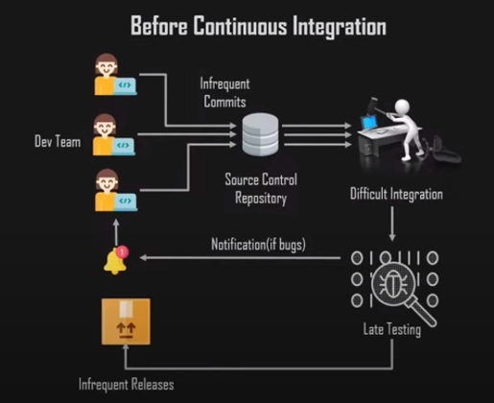

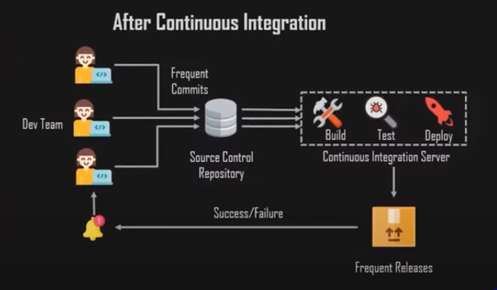

Continuous integration is a development practice in which the developers are required to commit changes to the source code in a shared repository several times a day or more frequently.

## **1.2. What is jenkins?**

Jenkins is an open source automation tool written in Java with plugins built for continuous integration purposes. Plugins allow integration of various Devops stages.

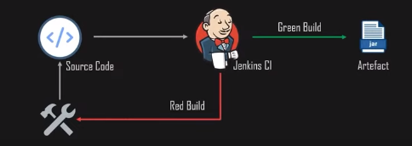

## **1.3. What is a pipeline?**

Jenkins pipeline is a combination of plugins that support the integration and implementation of continuous delivery pipelines using jenkins. A pipeline has an extensible automation server for creating complex delivery pipelines as code.

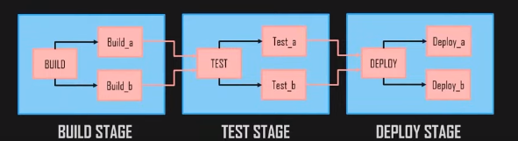

They are two approach

1. Declarative → Groovy Syntax
2. Scripted → strict and Traditional

## **1.4. What is a jenkinsfile?**

A jenkinsfile is a text file that contains where we define our entire structure and syntax of our jenkins.

## **1.5. Jenkins workflow**

* Developers commit changes to the source code:

Jenkins workflow always starts with the version control system or Source code repository.

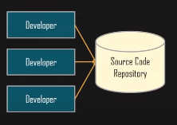

* CI server pulls that code, triggers a build

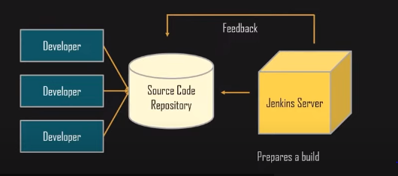

* The build application is deployed on the testing server

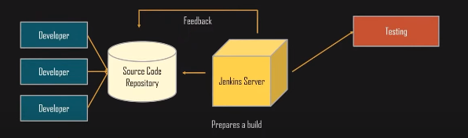

* Then the application is deployed on the production server

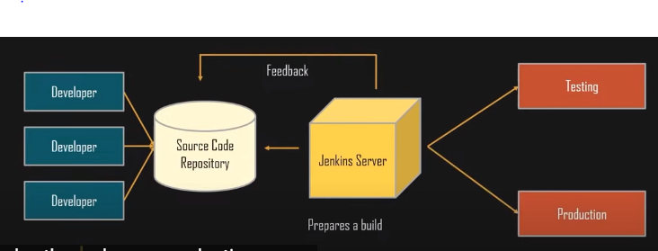

Create a pipeline on jenkins to execute a job which does the following tasks:

* Pull code from git
* Define environment variables
* Run unit tests
* Compile and package code
* Build code
* Combine this code into an article in a .jar format

# 

# 

# **2. Installation**

## **2.1. Installation of Java**

Jenkins requires Java to run. Install OpenJDK

sudo apt update

sudo apt install fontconfig openjdk-17-jre

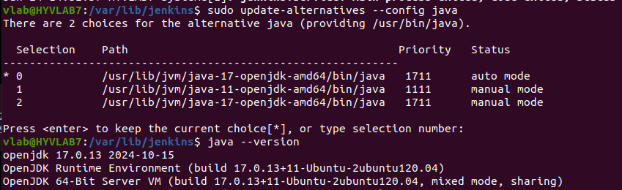

## **2.2. Installation of Jenkins**

sudo wget -O /usr/share/keyrings/jenkins-keyring.asc \

https://pkg.jenkins.io/debian-stable/jenkins.io-2023.key

echo "deb [signed-by=/usr/share/keyrings/jenkins-keyring.asc]" \

https://pkg.jenkins.io/debian-stable binary/ | sudo tee \

/etc/apt/sources.list.d/jenkins.list > /dev/null

sudo apt-get update

sudo apt-get install jenkins

### **2.2.1. Access the Jenkins Web Interface**

By default, jenkins run on port 8080

http://<your-server-ip>:8080

<https://172.16.203.85:8080>

The first time you access jenkins, you’ll be prompted to unlock it.

Jenkins generates a random password during installation.

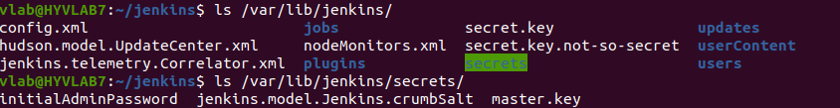

This will print the default password to the terminal

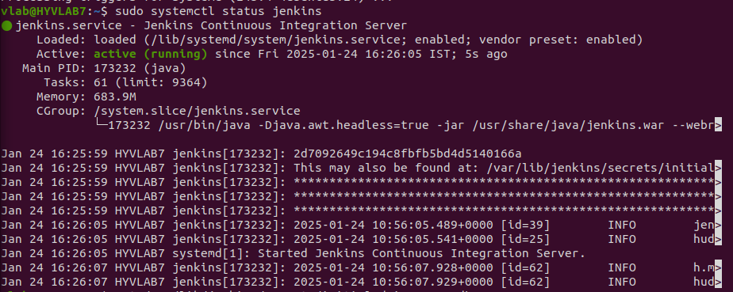

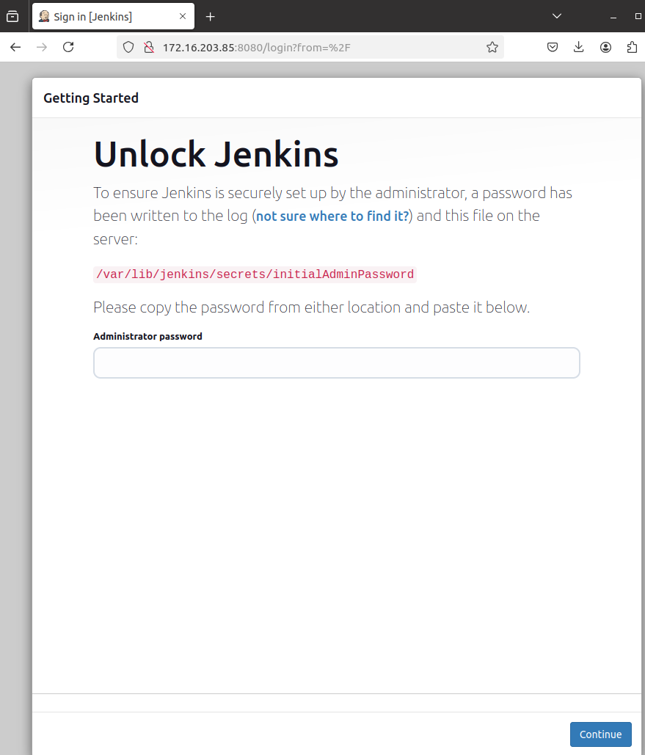



### **2.2.2. Set user and password**

After the above step it asks to create a user and password for admin configurations

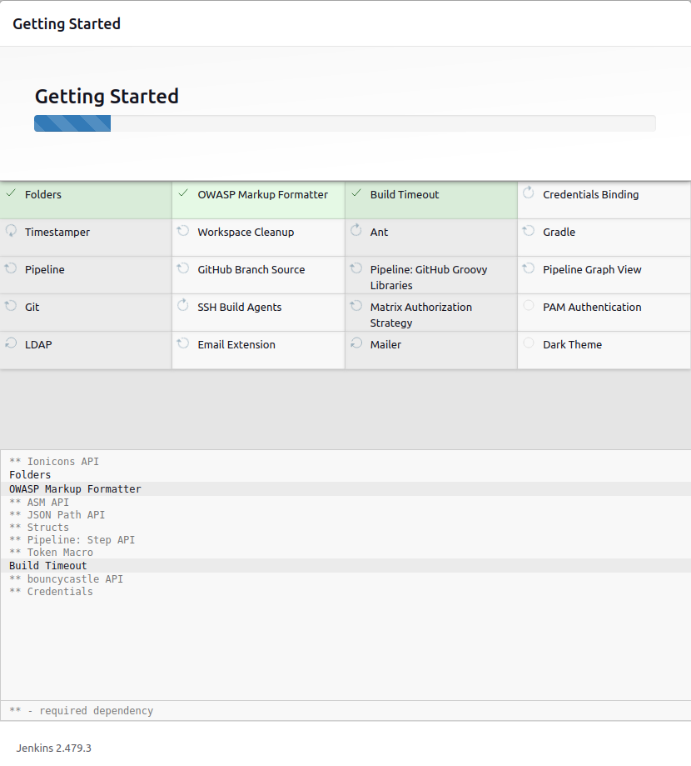

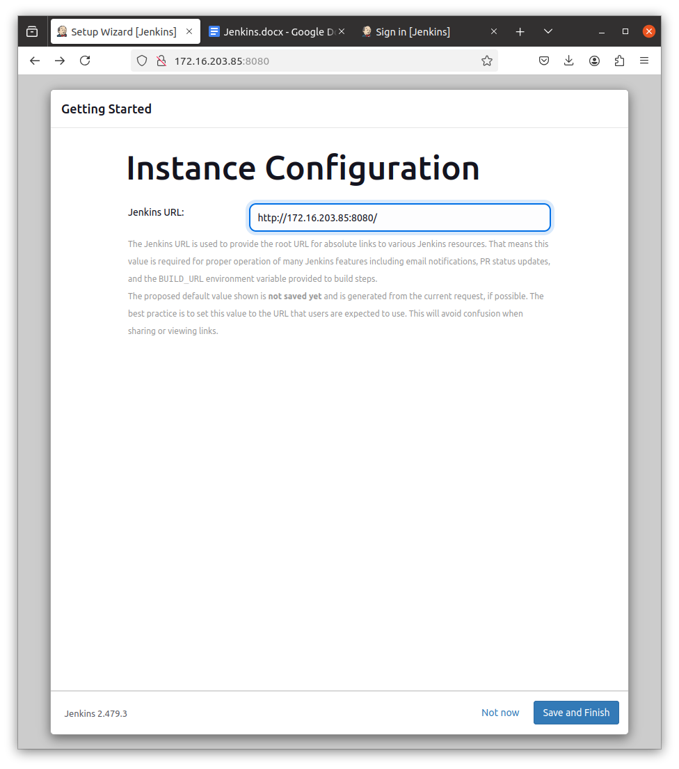

After reset the password successfully

Automatically removed this file /var/lib/jenkins/secrets/initialAdminPassword

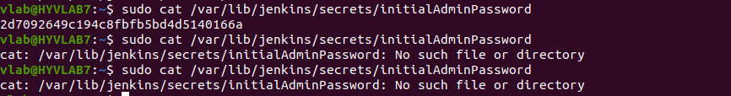

Check the user list

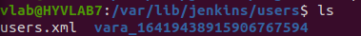

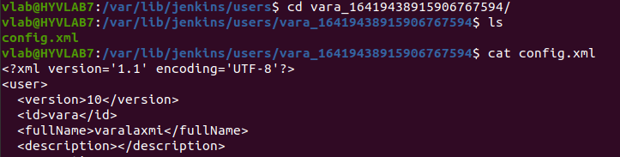

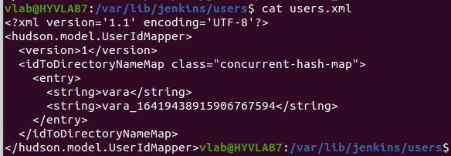

## **2.3. Email Notifications**

### **2.3.1. Extended Email Notification (Email Extension Plugin)**

* This plugin allows administrators to create global templates for the Extended Email Publisher.
* Provides **advanced email customization**.
* Supports **multiple triggers** (Success, Failure, Unstable, Always, etc.).
* Allows **custom email templates** with Groovy scripts and HTML formatting.
* Can send **attachments** (logs, reports, build artifacts).
* Supports **conditional email sending** based on build parameters.

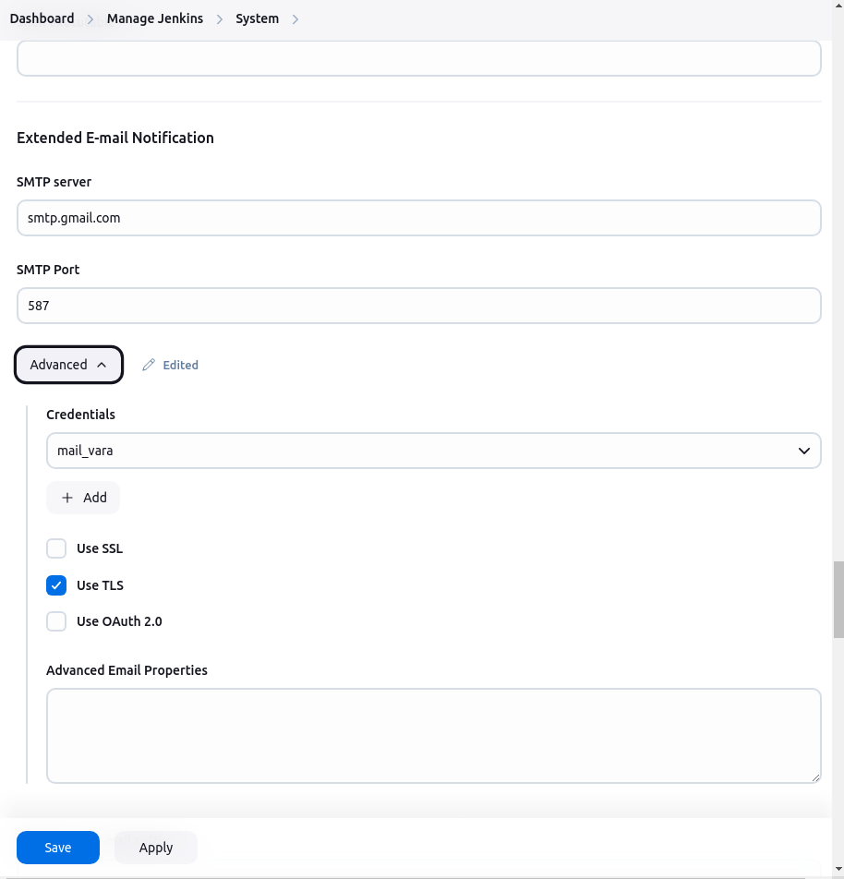

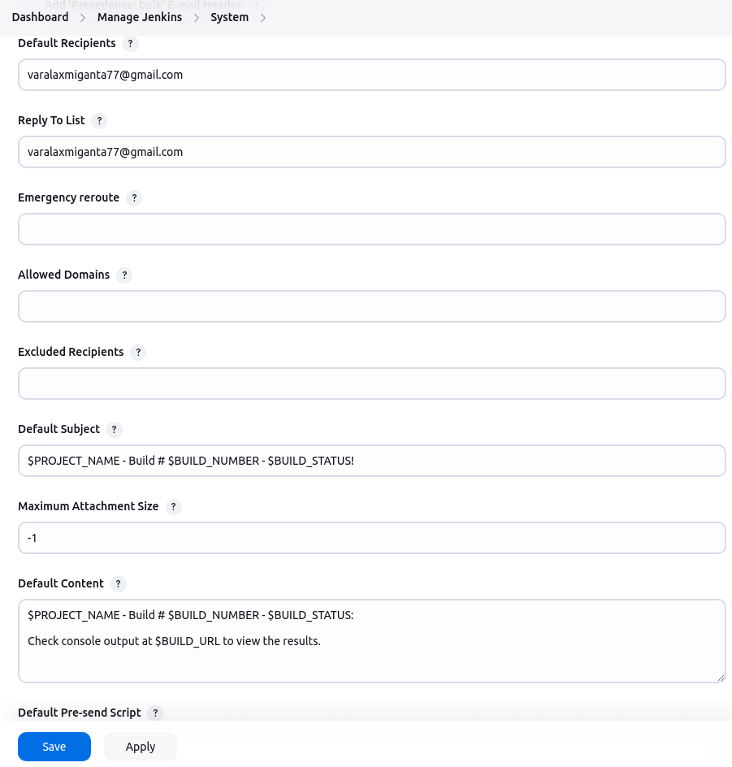

### **2.3.2. E-mail Notification (Mailer Plugin)**

* **Basic built-in feature** in Jenkins.
* Sends email only **on job failure**.
* Requires **SMTP settings** in **Manage Jenkins → System**.
* Cannot customize email content beyond the default format.\

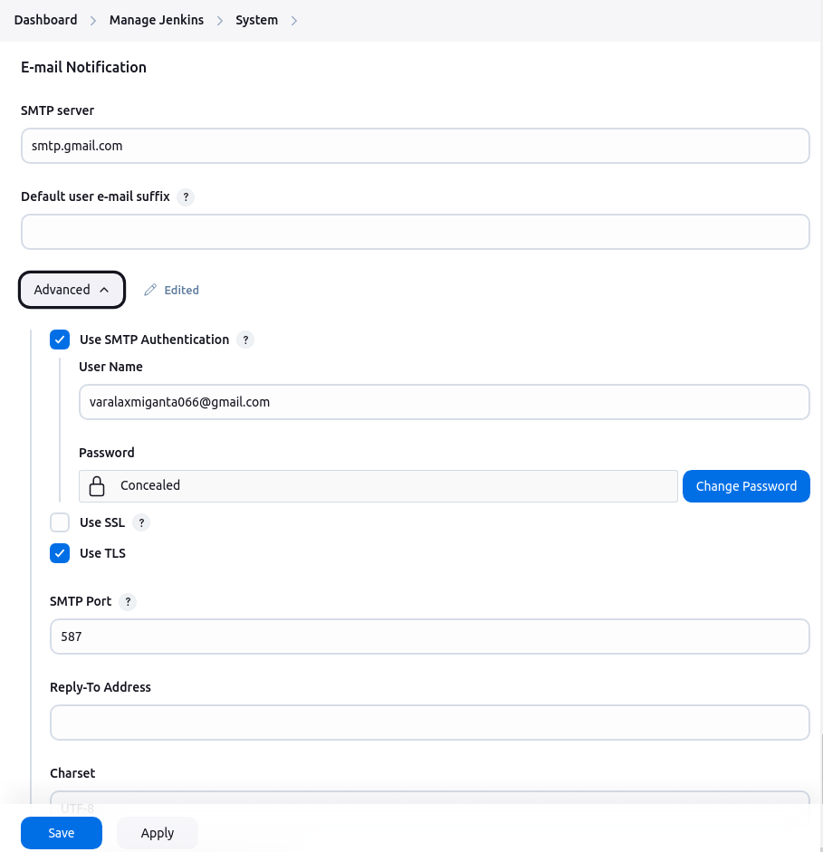

### **2.3.3. Setup**

* Enable 2-step verification.
* Generate an Application Specific Password:
  + Open the Google Account app on your phone, go to Google App Password
  + Once you are on the App Password page:
    - Give the app name (eg jenkins)
    - Click on create
    - Copy your app password for your device

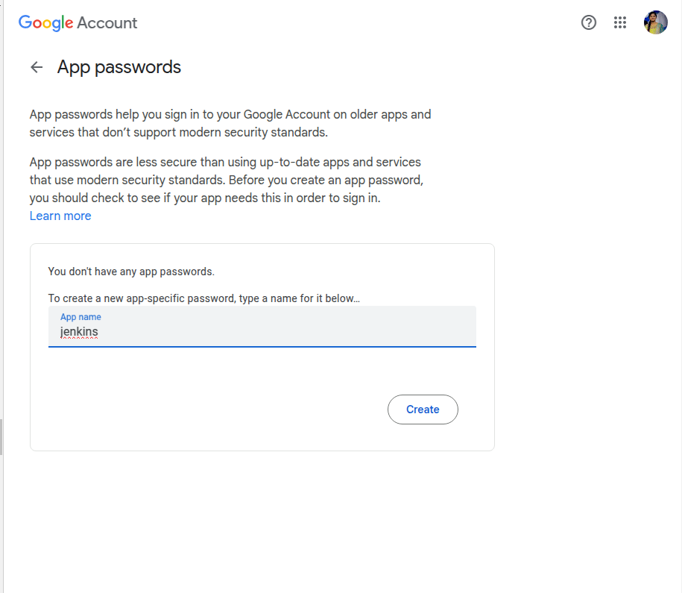

Password : nzyx kqkk qrbb qkzp

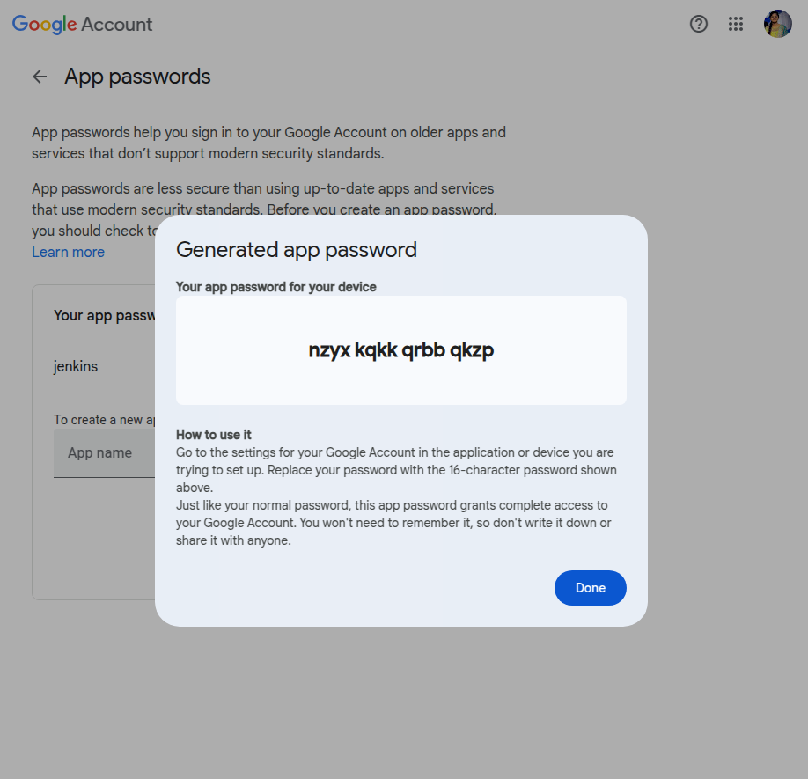

### **2.3.4. Configure the SMTP**

* Goto the jenkins dashboard → manage jenkins → system
* Scroll down to the E-mail Notification section.
* Enter the SMTP server address: smtp.gmail.com

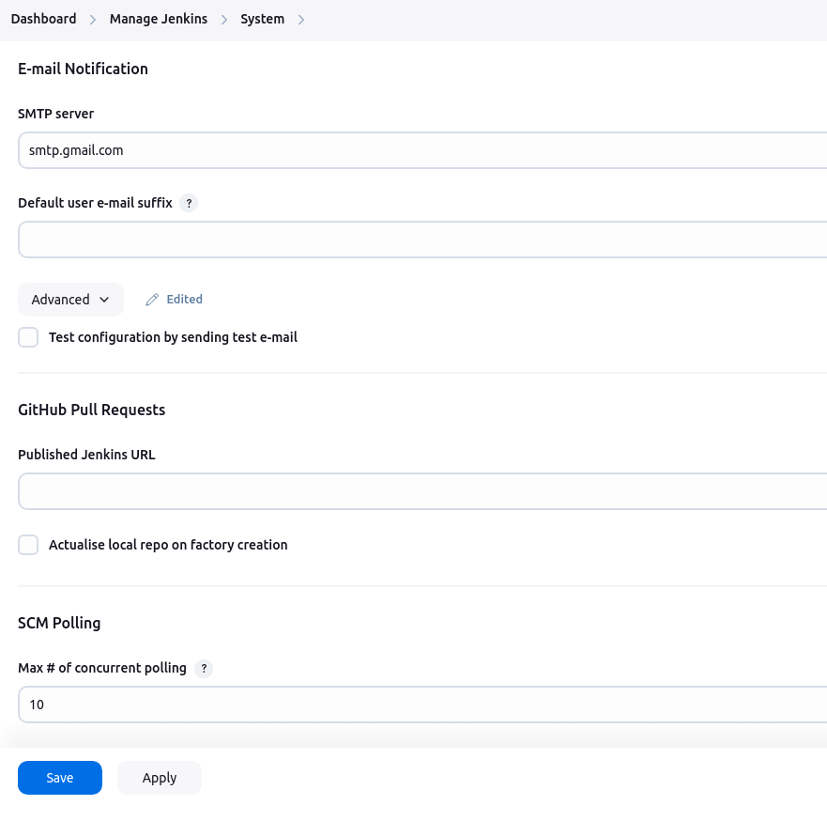

* Click on advanced
* Enter user name : [email-address@gmail.com](mailto:email-address@gmail.com)
* Enter app password
* Gmail uses port 465 for SSL or 587 for TLS.

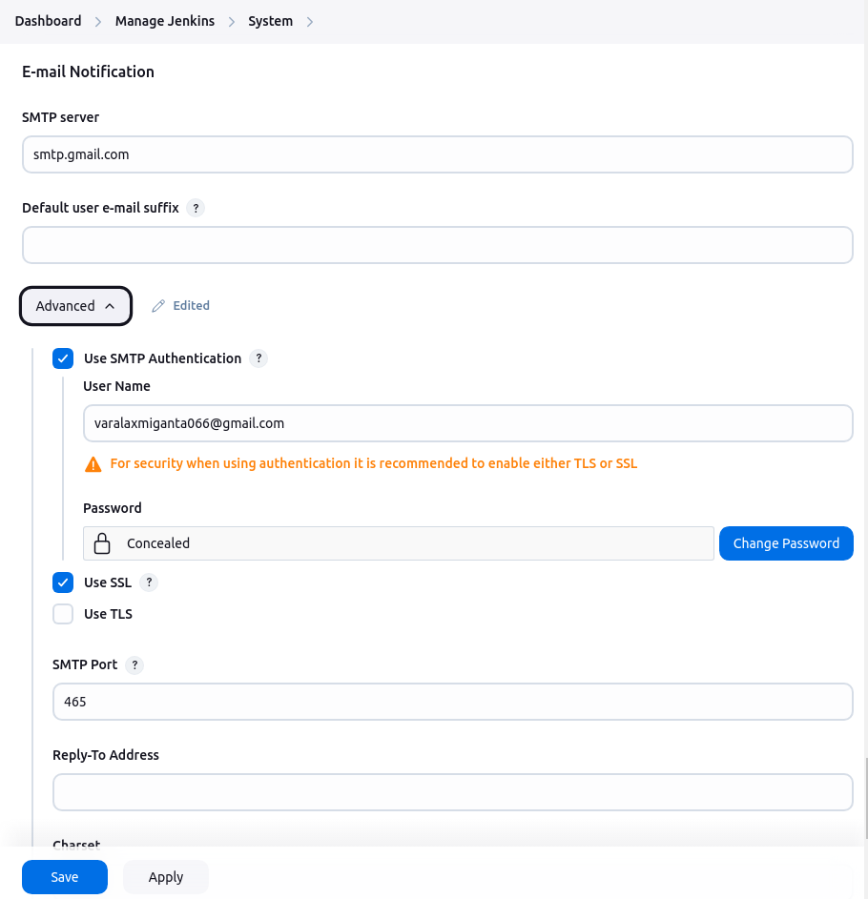

* Sender Email Address : This is the “from” address that will appear in the email notifications.
* Apply and Save.

**This is the test configuration by sending test email:**

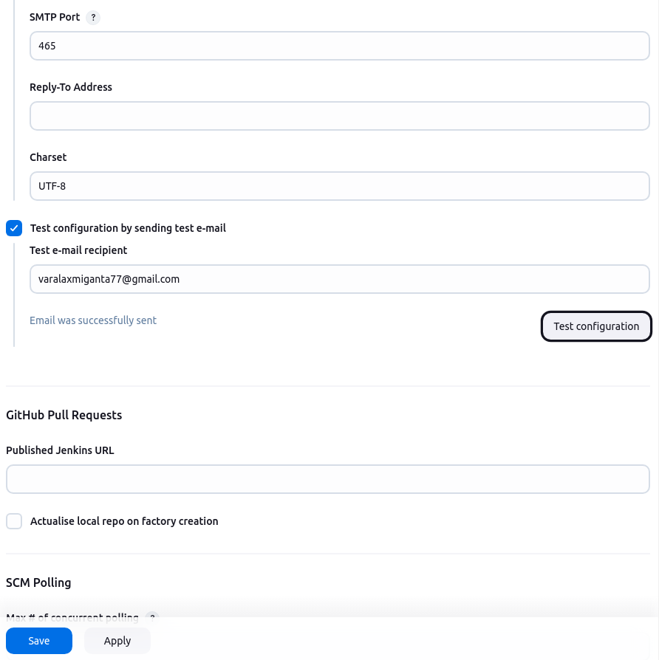

### 

### 

### 

### **2.3.5. Configure Email Notifications for a Job**

* Add the credentials to the manage jenkins

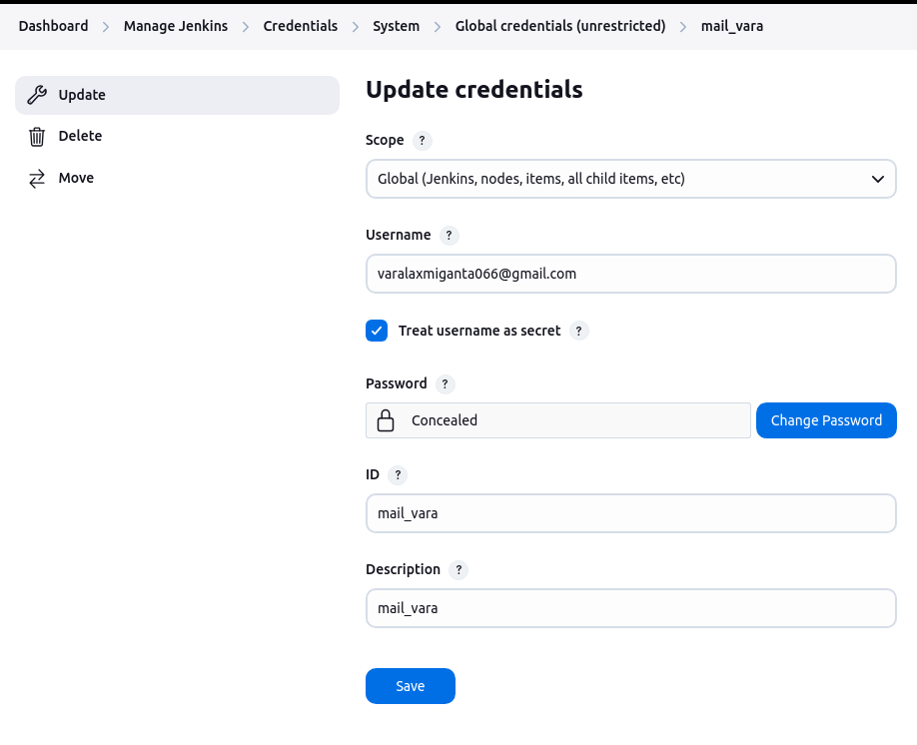

* Open your jenkins job
* Click on configure

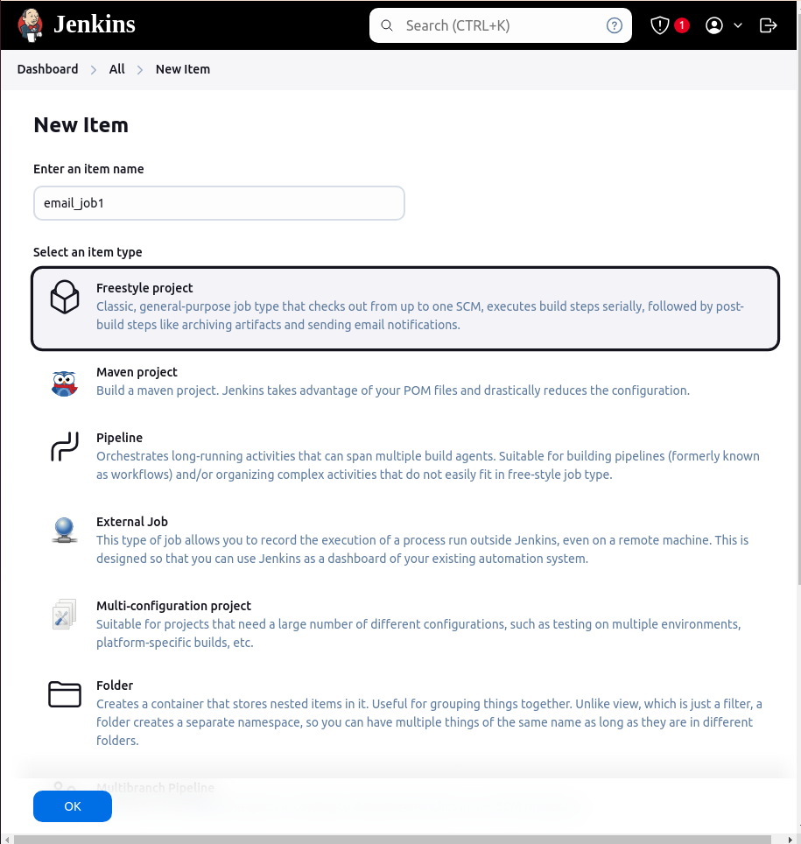

* Click **Add post-build action** → **Editable Email Notification**.

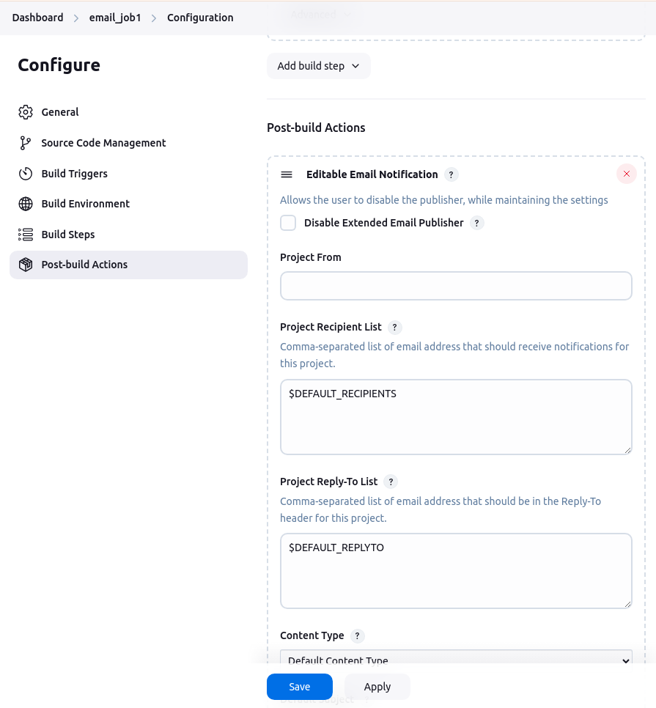

#### **2.3.5.1. Attach Build log**

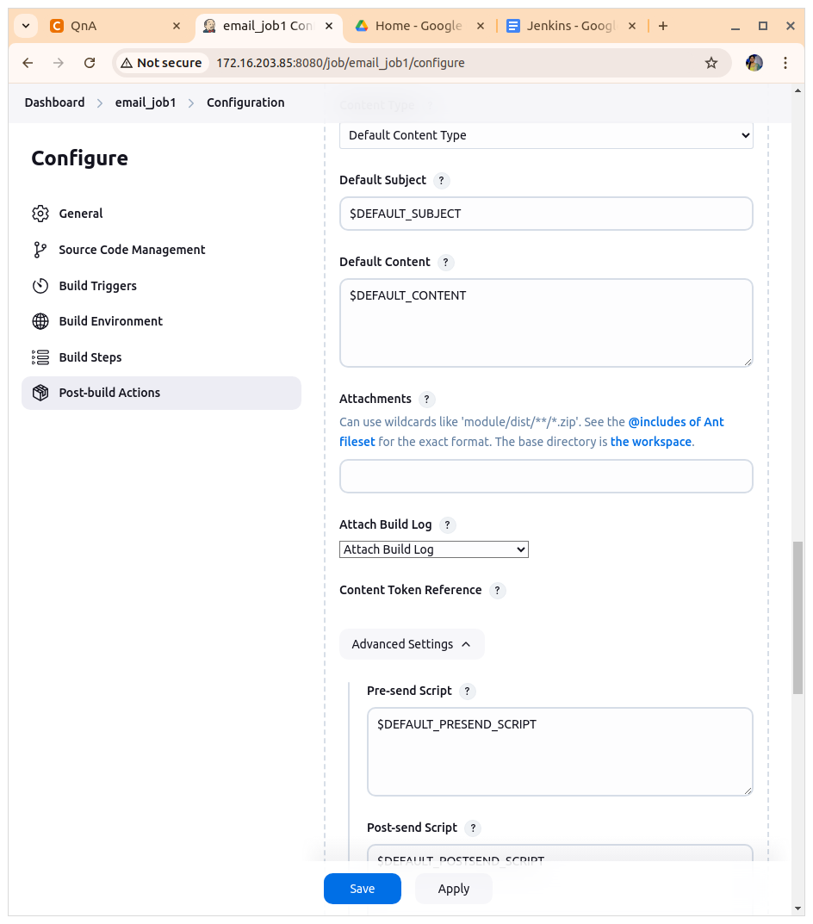

* Define **Triggers** (e.g., Success, Always, Unstable).
* Click save

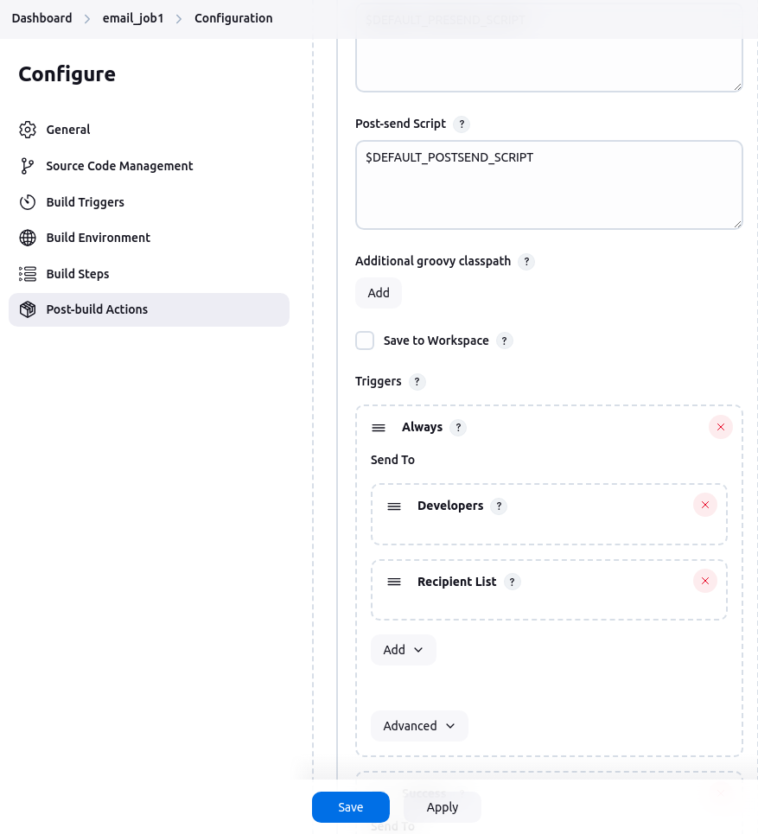

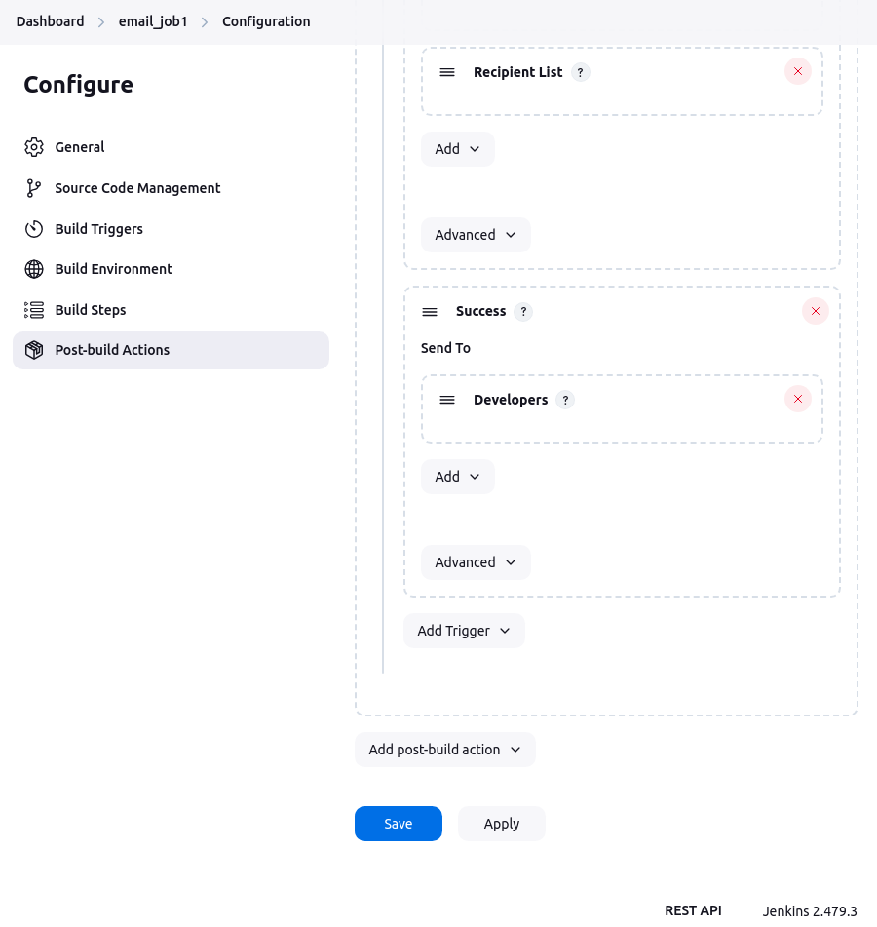

* Test Email Notifications
  + Run a build
  + Email will be sent on job completion
* Console Output

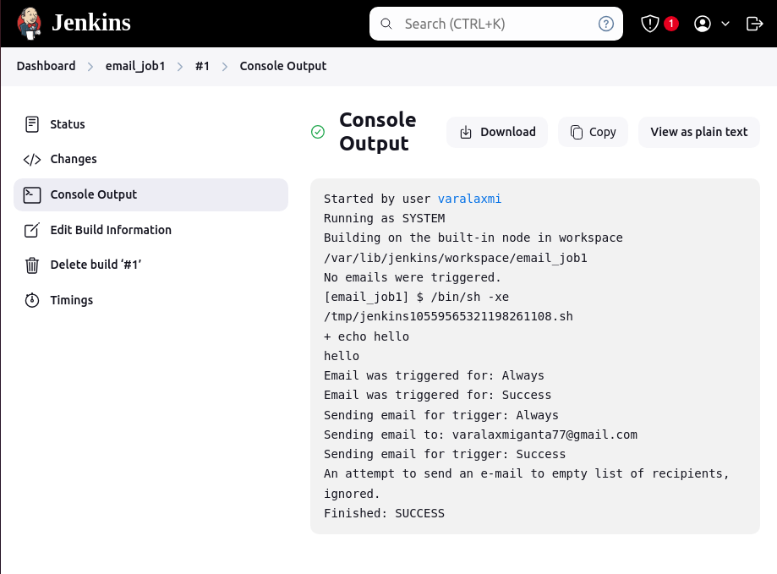

* Email Notification

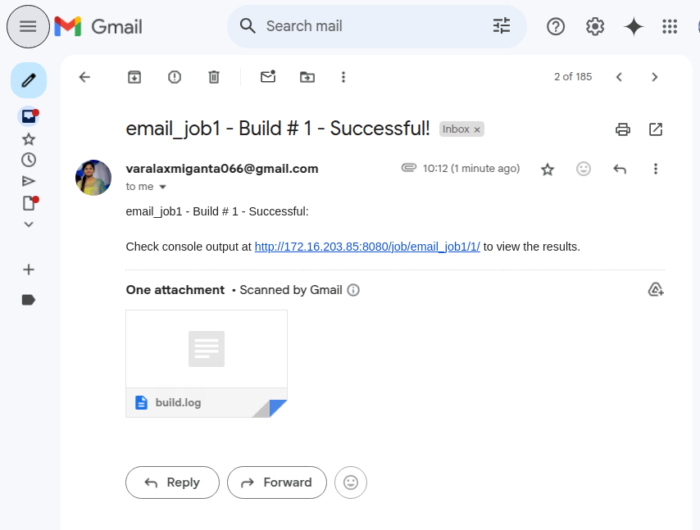

## **2.4. Test Results Analyzer Plugin**

* The **Test Results Analyzer** plugin provides a graphical view of test results over multiple builds, making it easier to track failures and trends.
* Go to **Jenkins Dashboard** → **Manage Jenkins** → **Manage Plugins**.
* In the **Available** tab, search for **Test Results Analyzer**.
* Click **Install**

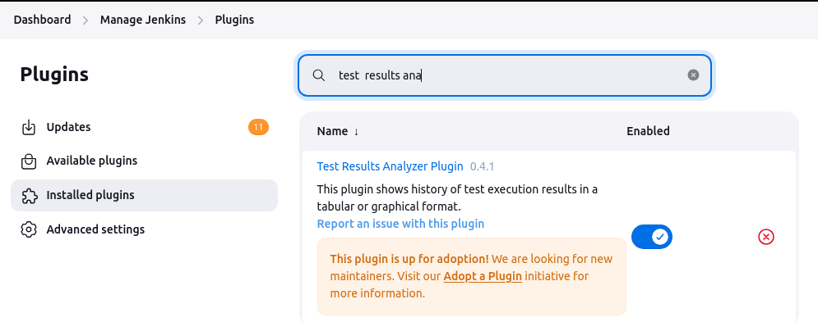

## 

# **3. Jenkins**

Welcome to jenkins dashboard

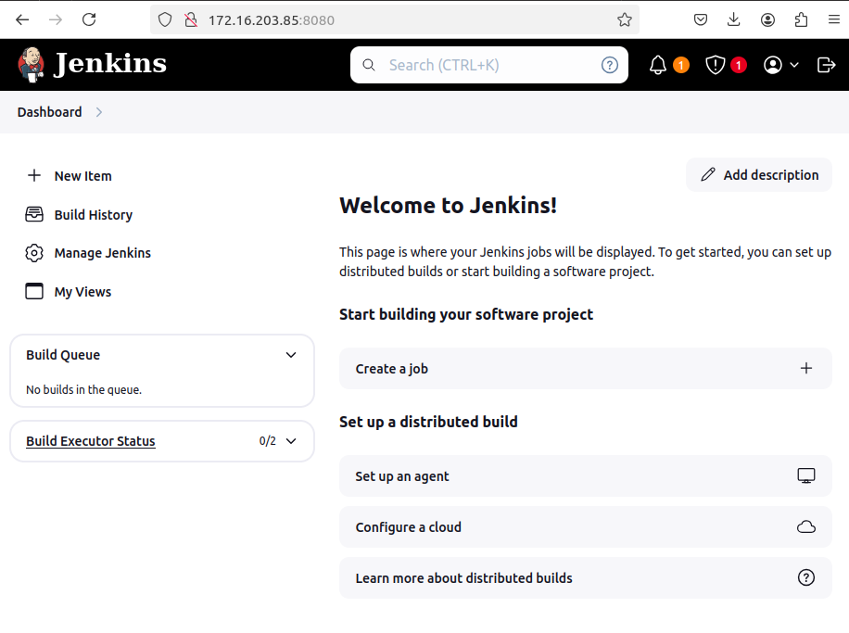

## **3.1. Reset the admin Password**

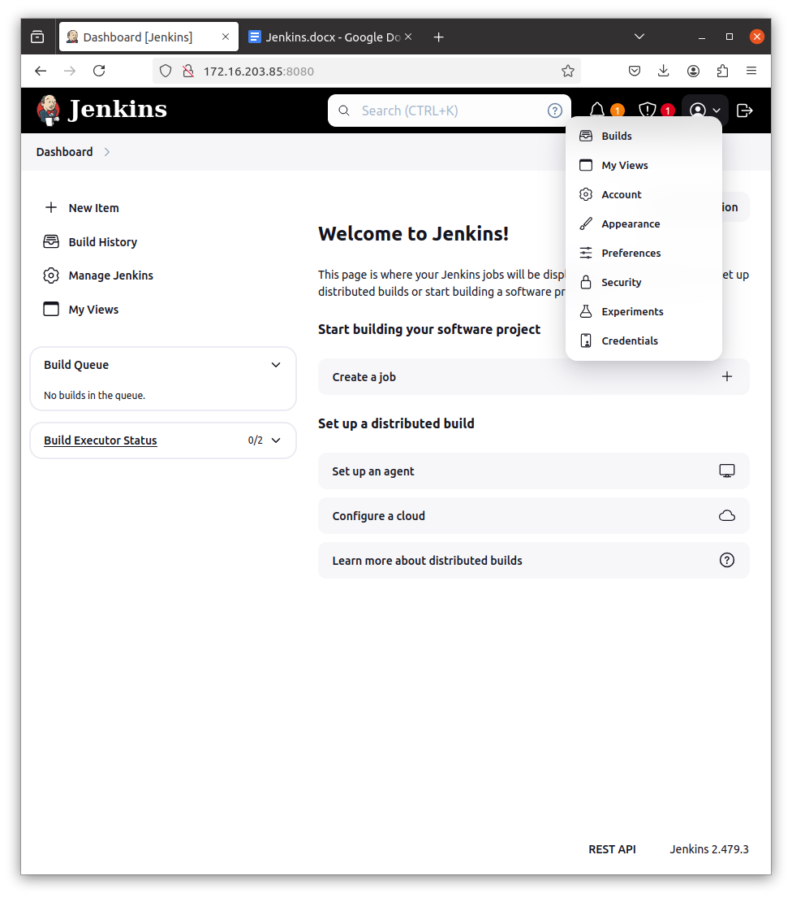

**This is the admin page**

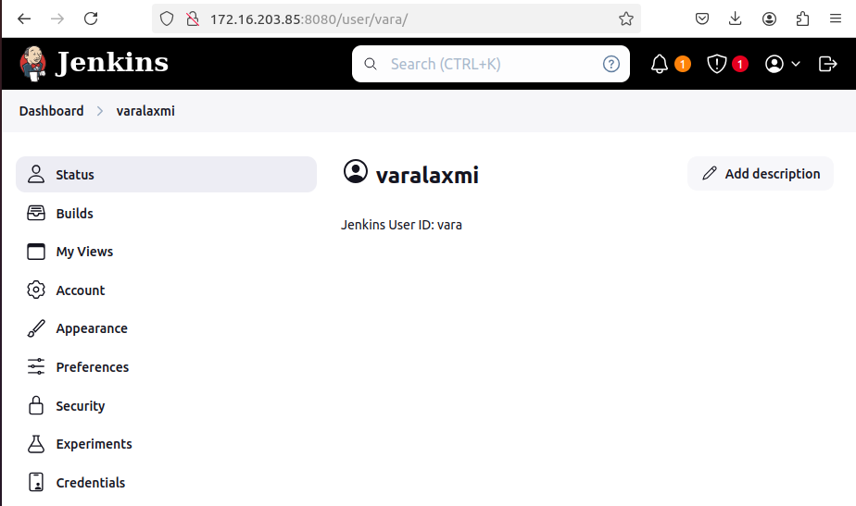

**Goto the Security the change password and save**

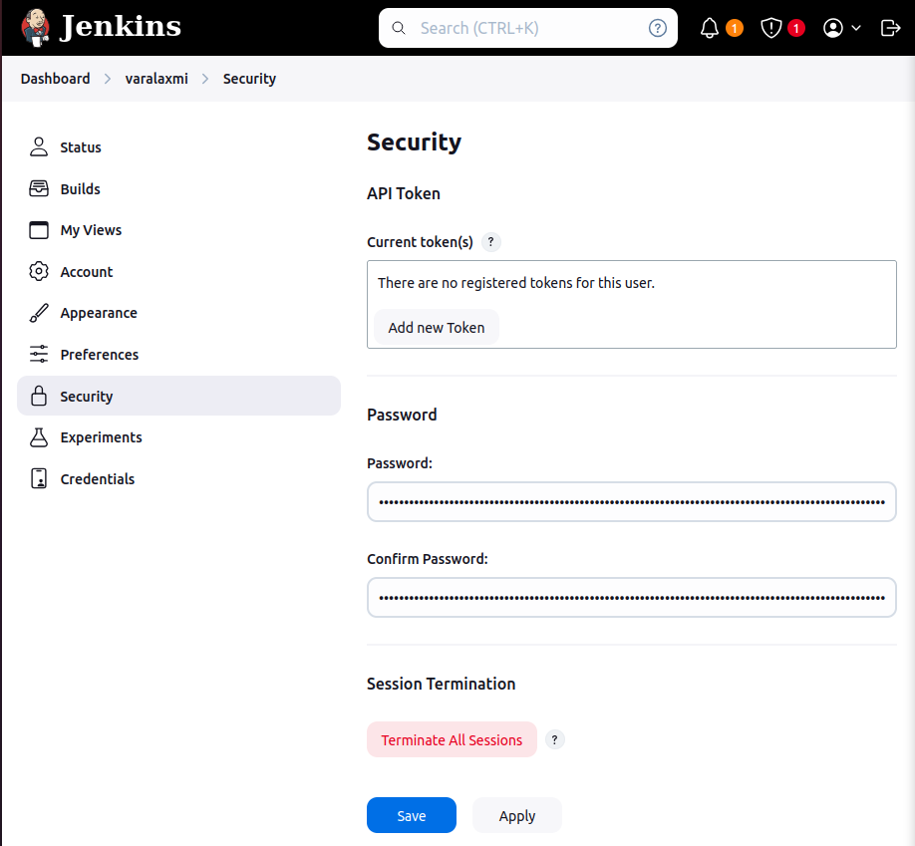

## **3.2. Available plugins**

To get the available plugins in jenkins

**Manage Jenkins ⇒ Plugins**

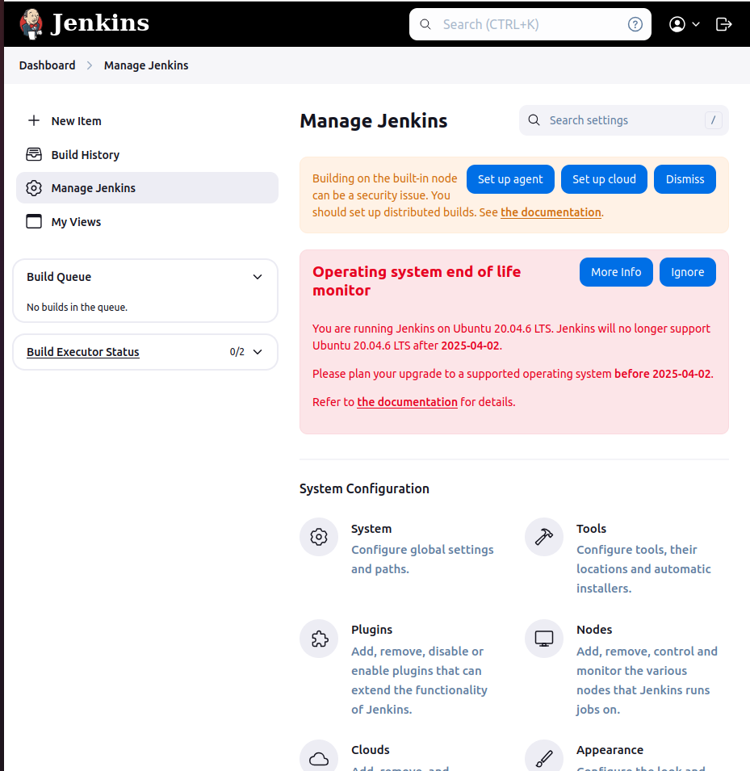

**Plugins ⇒ Available Plugins**

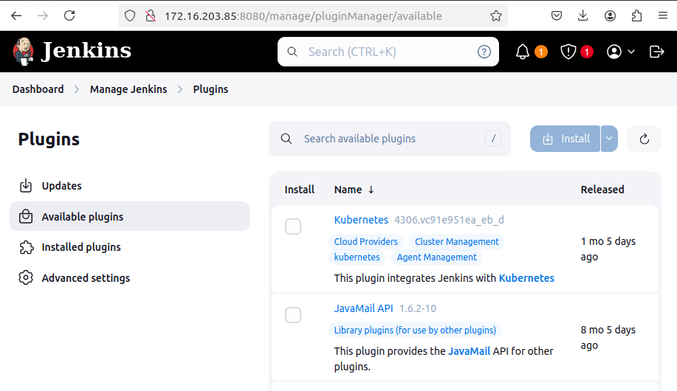

**Through cmd line**

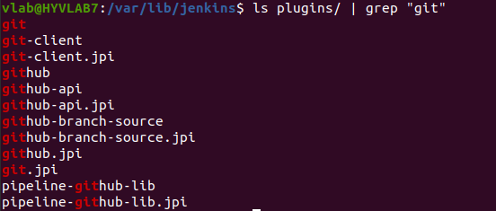

## 

## **3.3. Create Jobs**

* From the Jenkins Dashboard, click on "New Item" in the left-hand menu.

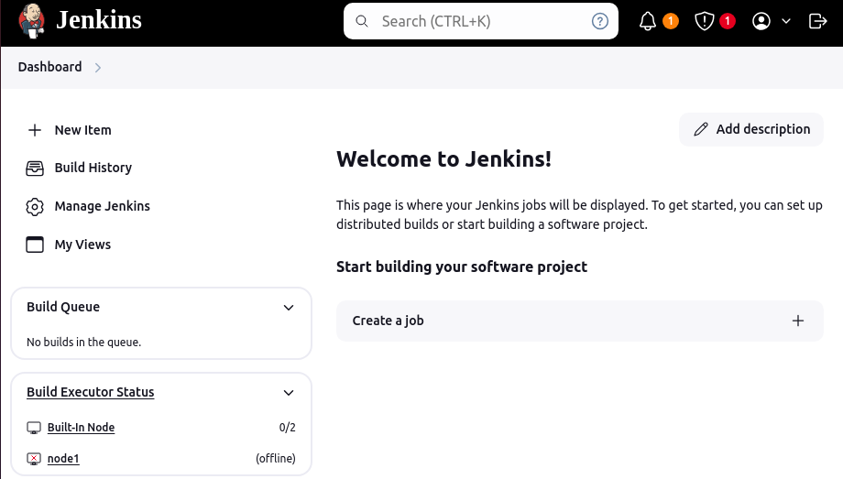

* Enter a name for your pipeline job (e.g., job1).
* Select "Pipeline" from the list of options.
* Click "OK".

### **3.3.1. Using Freestyle Project**

**Note : Install python plugin**

* Go to **Jenkins Dashboard** → **Manage Jenkins** → **Manage Plugins** → **Available** tab.
* Search for **"Python Plugin"** and install it.

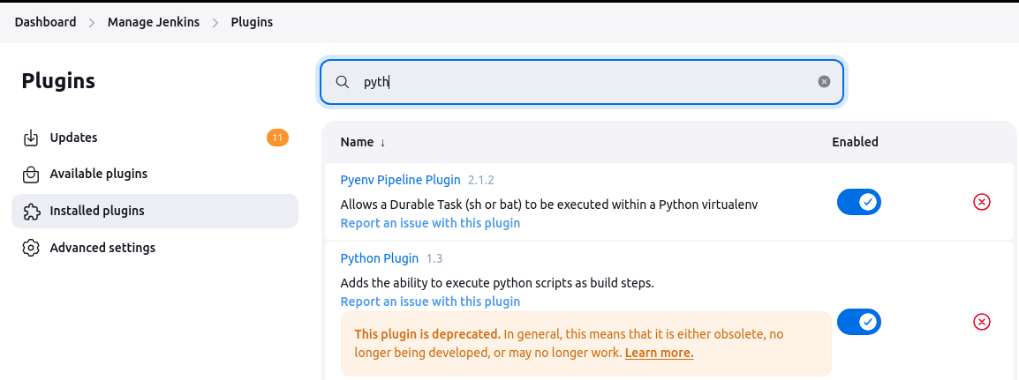

**Template**

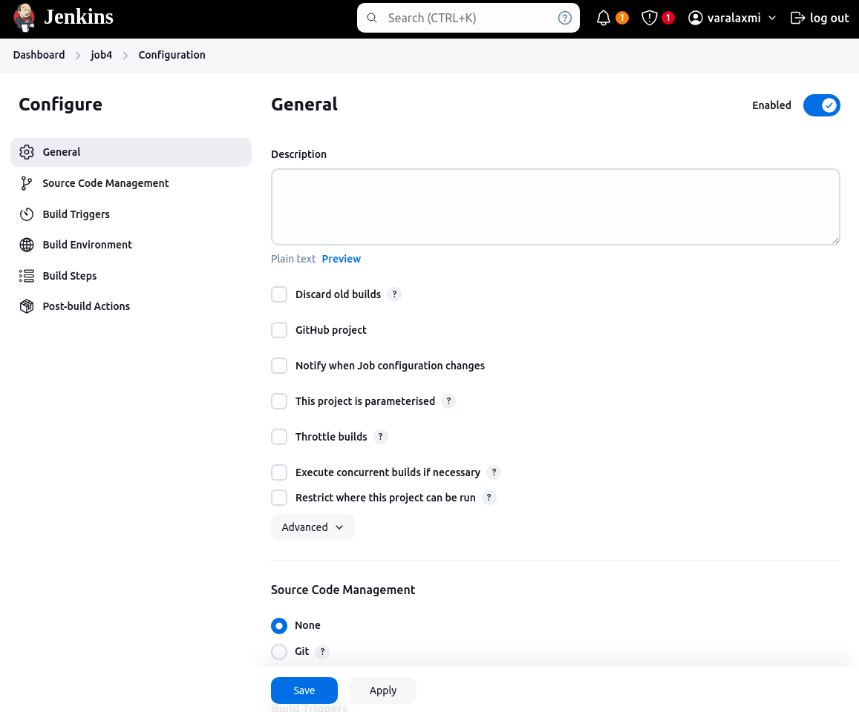

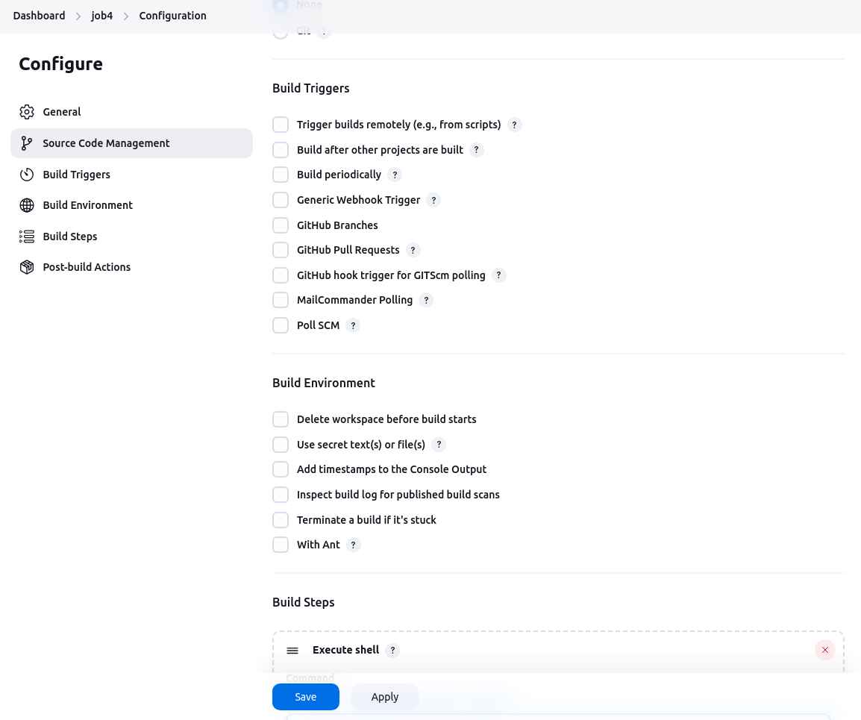

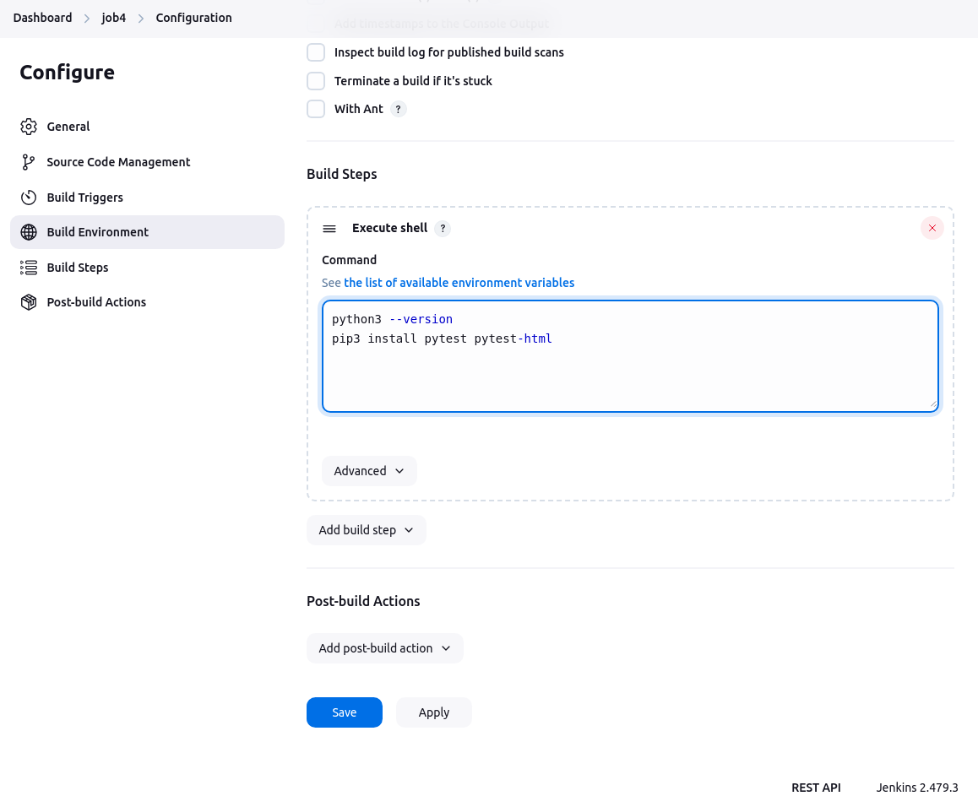

* Click save button after click on Build Now

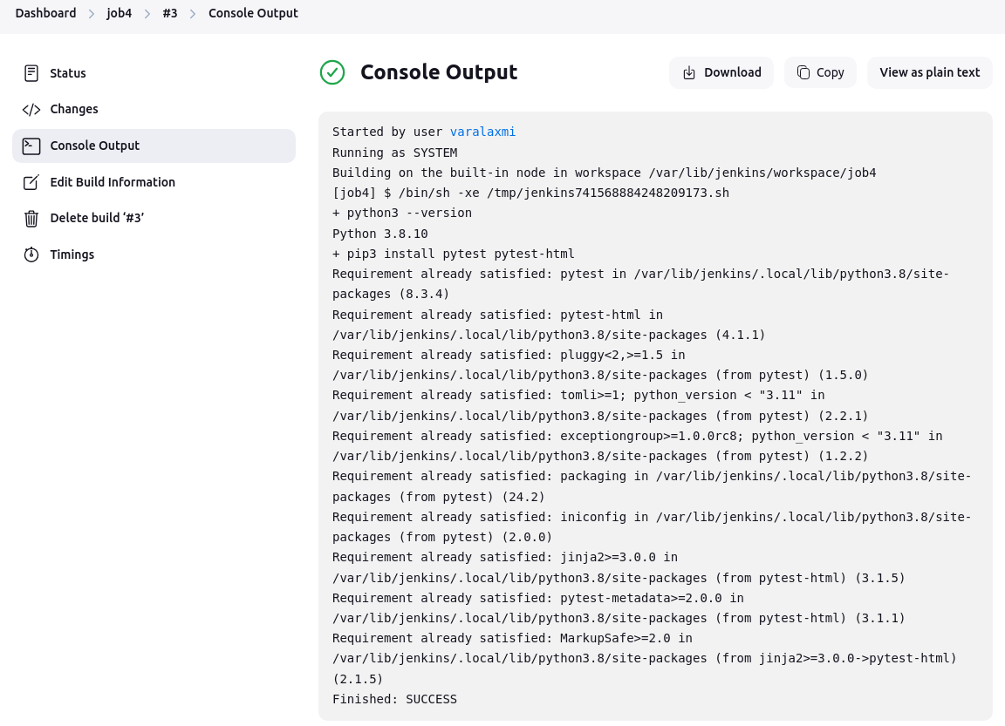

### 

### 

### **3.3.2. Using Pipeline**

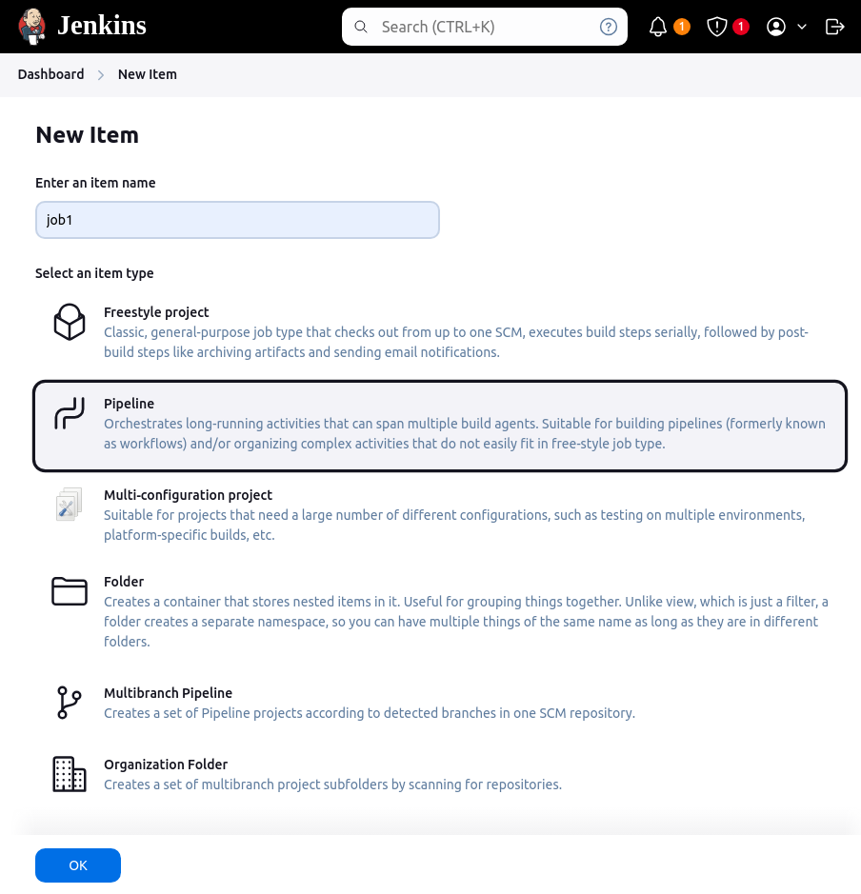

* Add a description for your pipeline.
* Select the **Pipeline script** option.
* Write the pipeline script directly in the Jenkins UI.
* Simple Hello World

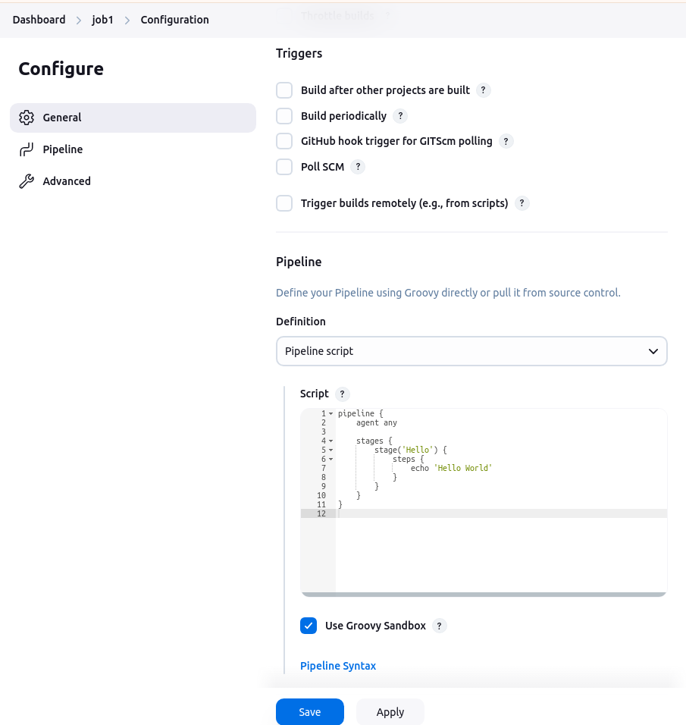

**Pipeline script :**

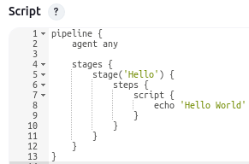

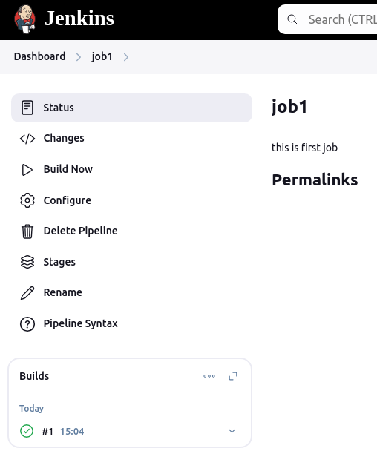

#### **3.3.2.1. Status**

* Success(Green): The job has completed successfully without any error or failures.
* Failure(Red): The job encountered errors during execution and was unable to complete as expected.

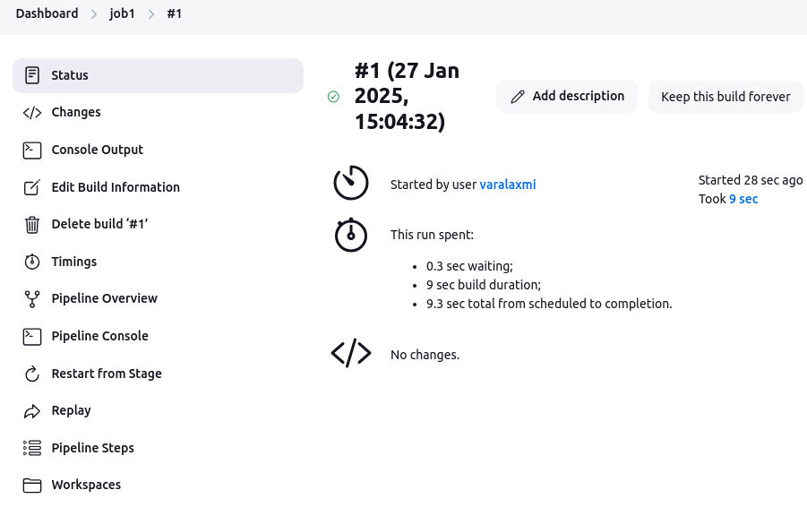

#### **3.3.2.2. Console Output**

* The **console output** in Jenkins refers to the log of messages and information generated during the execution of a job or pipeline.
* It provides a detailed trace of what happens during the execution, including any commands run, steps executed, and output from those steps (like errors, warnings, or success messages).

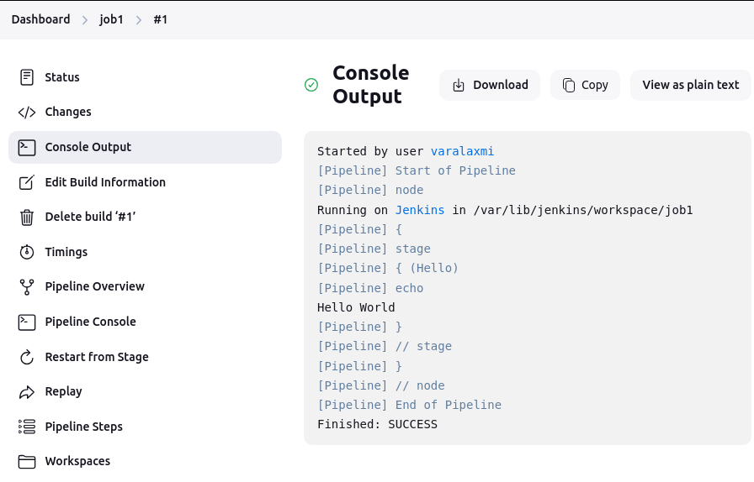

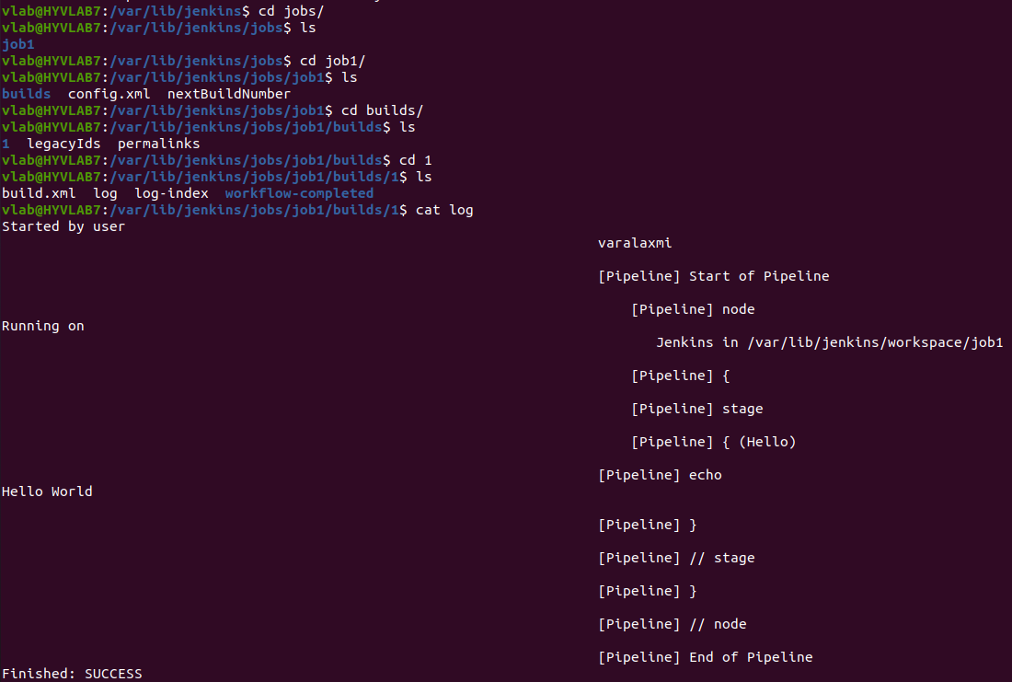

#### **3.3.2.3. No workspace Initially**



* When a pipeline is defined but does not involve any files creation or manipulation, jenkins does not create a workspace.
* This is because there are no resources or files that need to be stored or processed during the job executions.

#### **3.3.2.4. Workspace creation when files are needed**

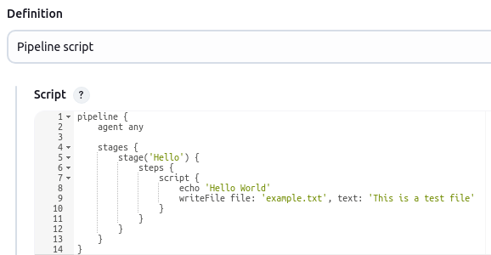

* If your pipeline includes steps that require creating or accessing files(eg.., creating a file, cloning a repository, reading a file) jenkins creates a workspace directory automatically.
* The workspace serves as the job’s working directory where jenkins performs file-related operations.

#### **3.3.2.5. Pipeline console**

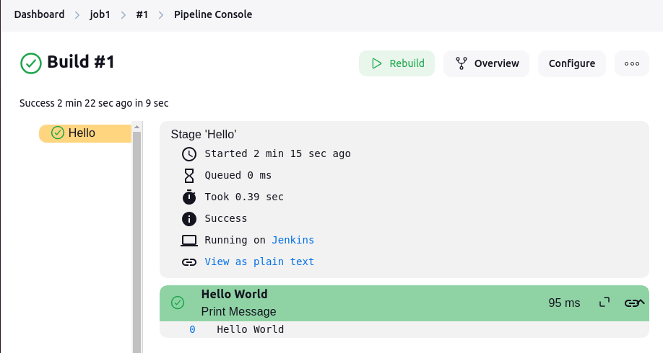

#### **3.3.2.6. Replay**

* In Jenkins, **Replay** is a feature that allows you to re-run a previously executed pipeline with modified code, typically from the Jenkinsfile.

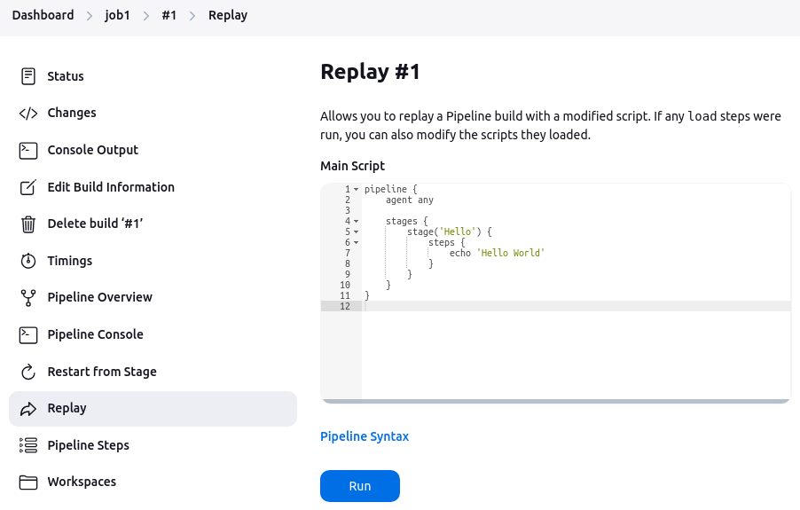

#### **3.3.2.7. Pipeline Steps**

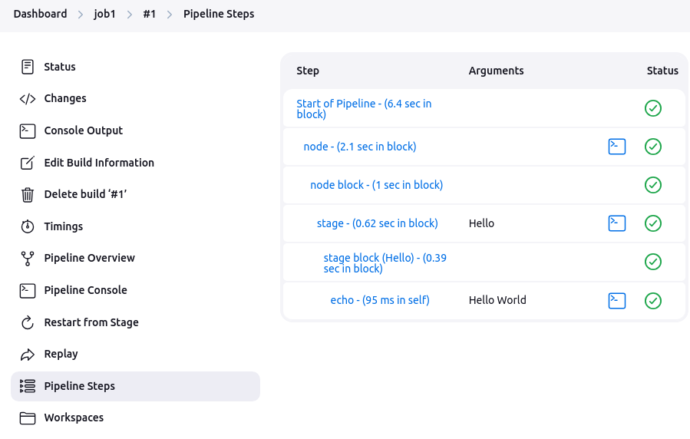

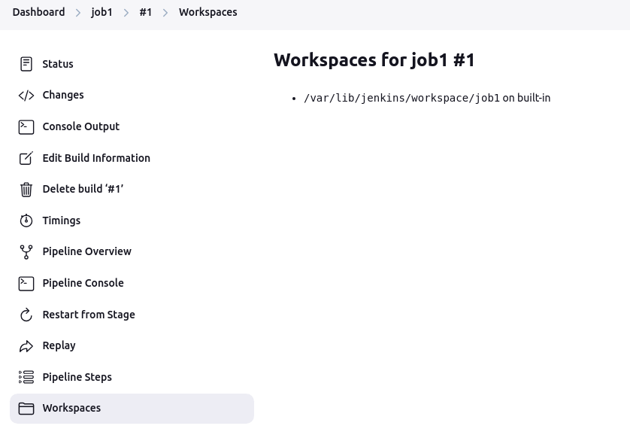

#### **3.3.2.8. Generate Pipeline Script**

* **agent { label 'agent1_66' }**This tells Jenkins to run the entire pipeline on any node that has the label agent1_66.
* **stages { ... }**The pipeline is broken into several stages (Checkout, Build, Test, Deploy). Each stage can contain one or more steps.
* **steps { ... }**Each state's steps include commands (like echo or shell commands via sh) that will be executed on the selected node.
* **post { ... }**The post section lets you specify actions that occur after the pipeline completes, whether it was successful or not. Here, for example, it cleans up the workspace and prints a success or failure message.
* **Open a Job with Pipeline Configuration:**
  + If you already have a Pipeline job, go to its configuration page.
  + If not, create a new Pipeline job by selecting "New Item" and choosing "Pipeline".
* **Access the Snippet Generator:**
  + Scroll down to the "**Pipeline**" section of the job configuration.
  + Click on the "**Pipeline Syntax**" link (often located at the bottom of the configuration page).

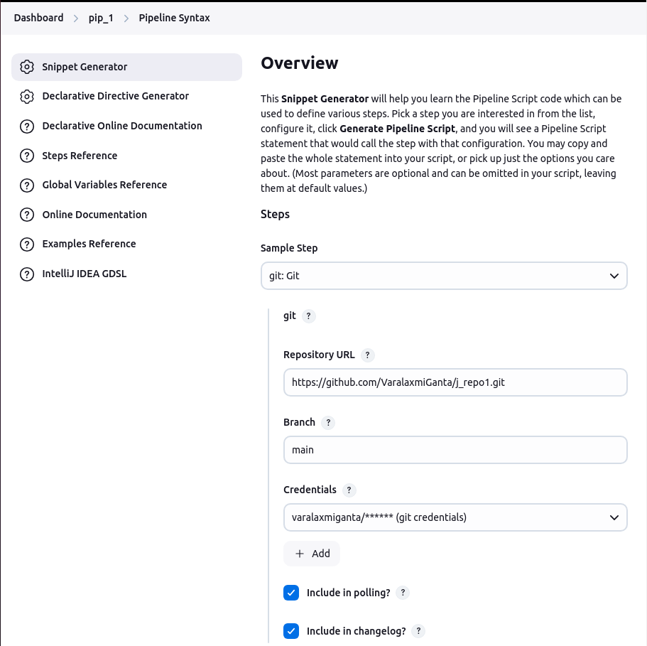

* **Generate a Snippet:**
  + In the Pipeline Syntax page, choose the type of step you want to generate (for example, **"sh"** for shell commands, **"git"** for source control, etc.).
  + Enter the Repo URL, branch and give the credentials.
  + Click **"Generate Pipeline Script"**.
  + The generated Groovy snippet will appear. You can copy this snippet and paste it into your Jenkinsfile or Pipeline script.

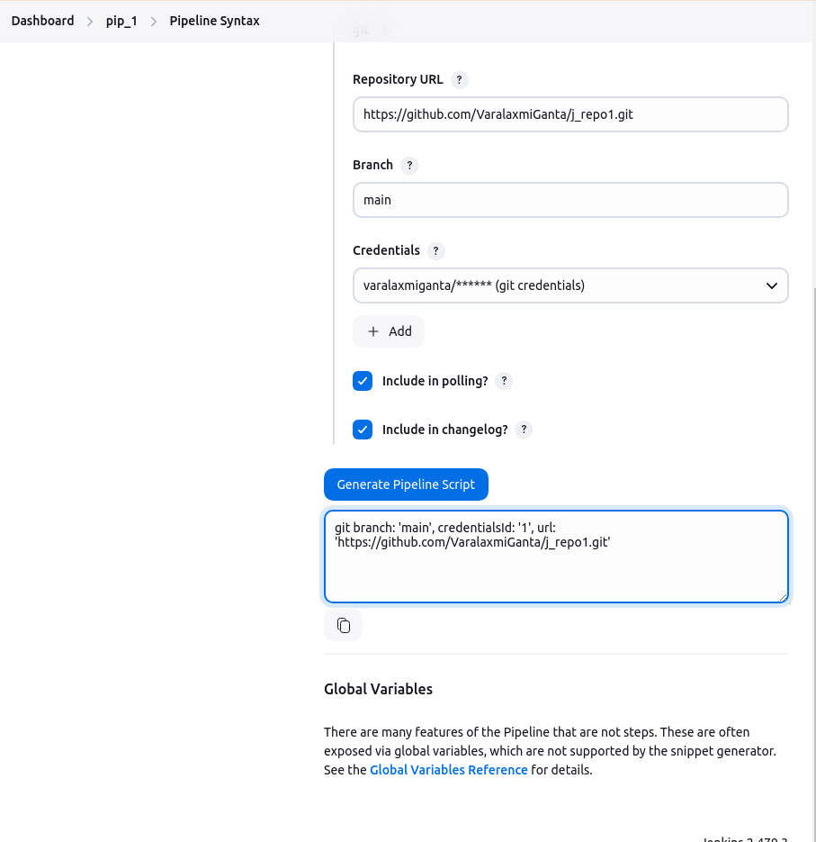

* After past it into your pipeline script and save it

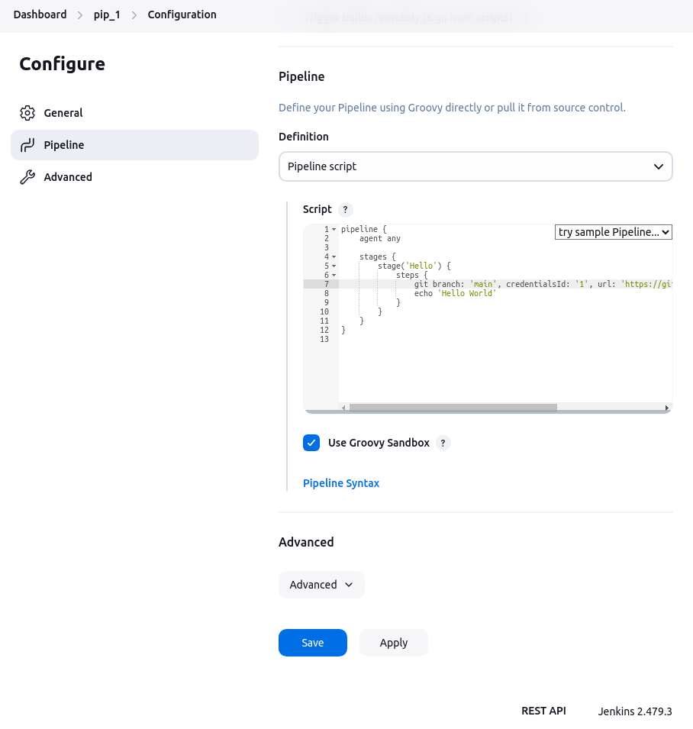

* Click on build now and observe the console output.

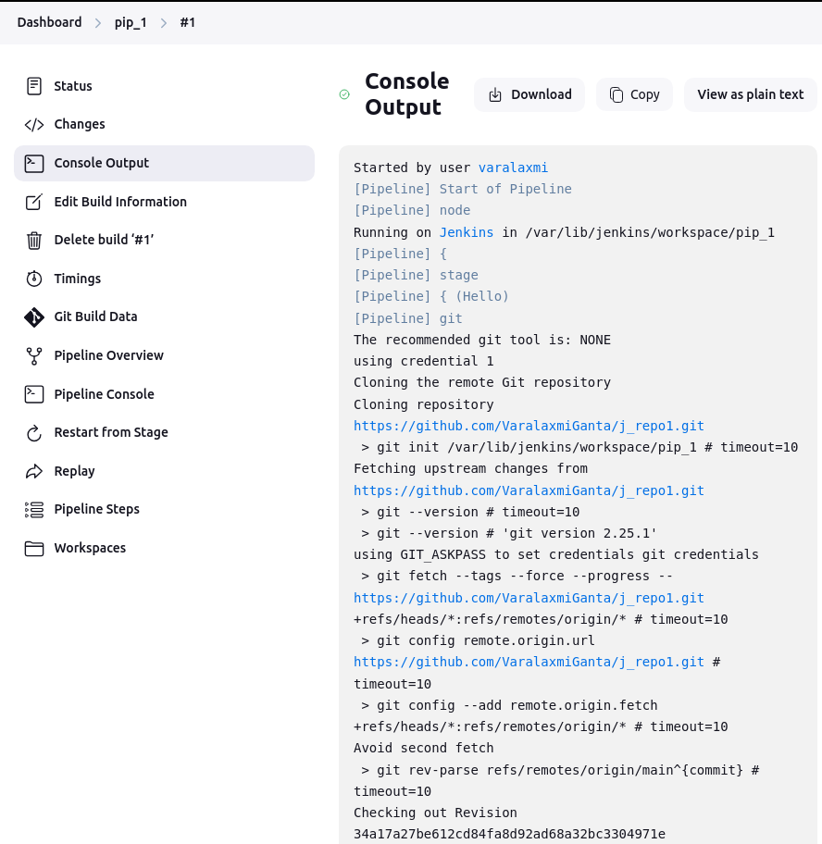

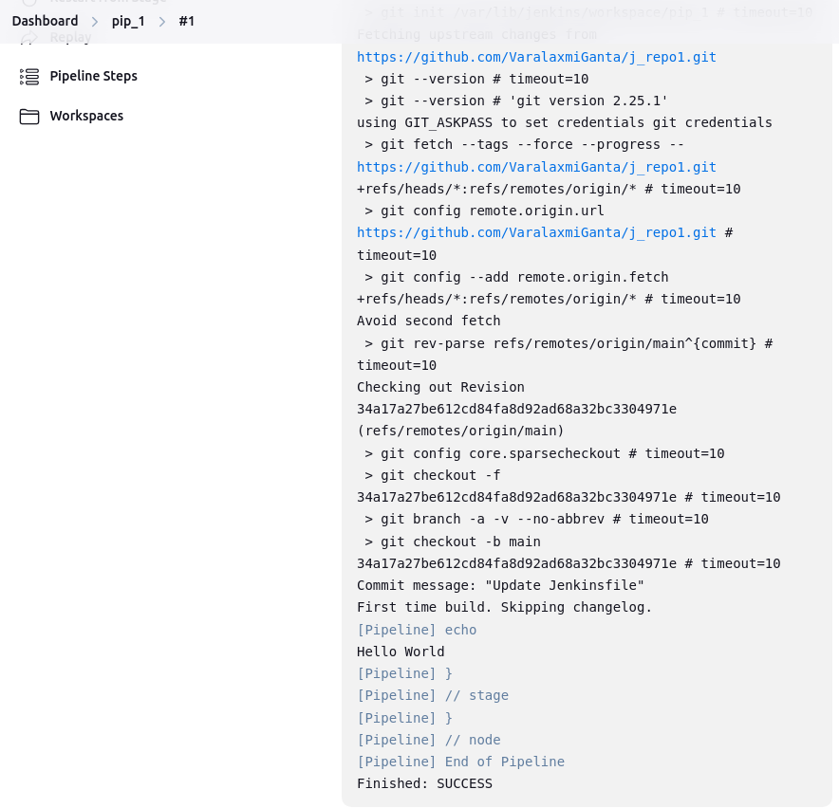

### **3.3.3. Using Maven Project**

* Maven is a build automation and project management tool primarily used for Java projects. It simplifies the process of building, testing, and packaging projects, managing dependencies, and creating reports.
* A Maven project is a software project managed using **Apache Maven**. A Maven project uses a **pom.xml** file (Project Object Model) to define the configuration and structure of the project. This file contains information such as dependencies, build settings, plugins, and other configurations.

#### **3.3.3.1. Maven Integration Plugin**

* Install Maven Integration Plugins

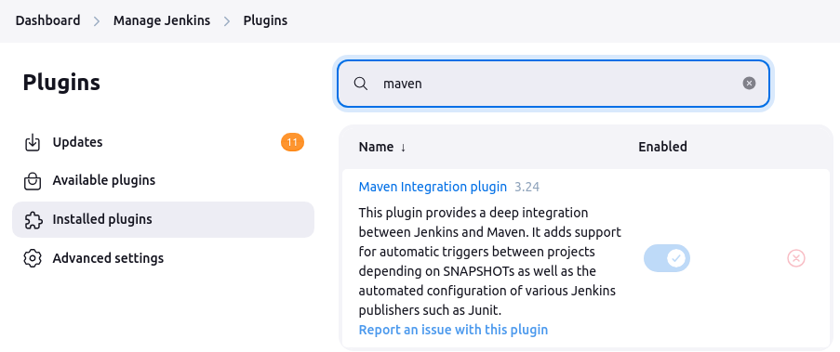

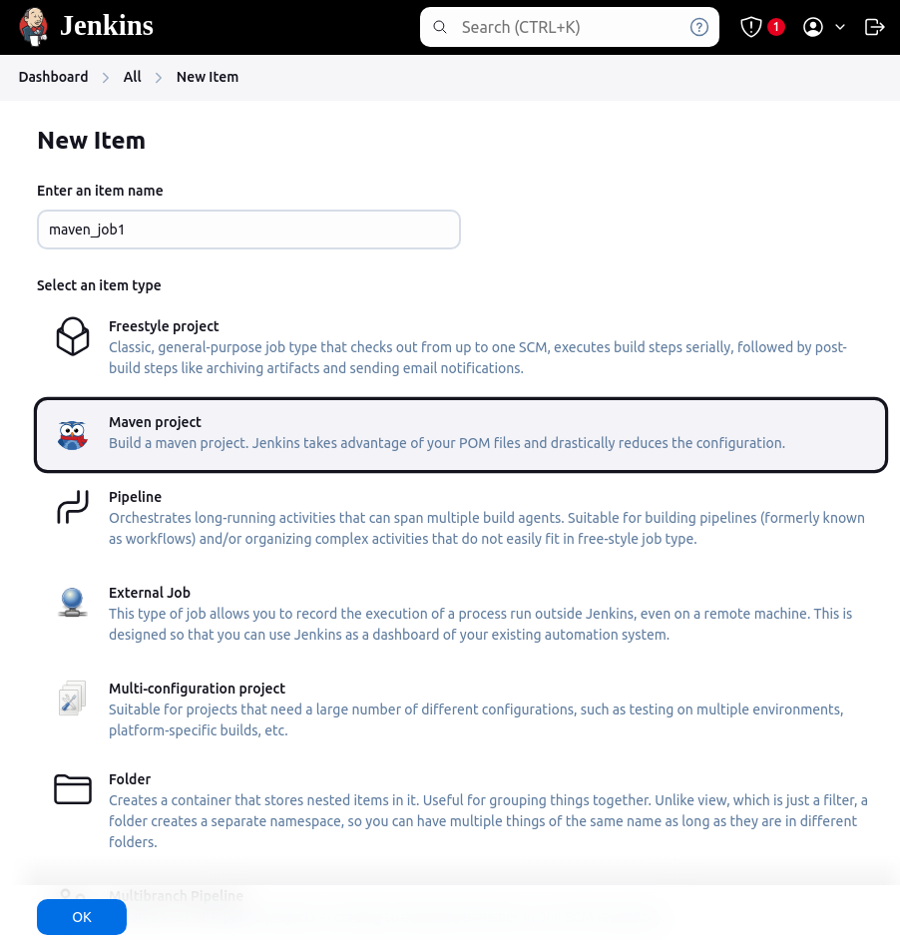

## **3.4. Nodes**

* In Jenkins, a **Node** is a machine (physical or virtual) where Jenkins runs jobs (builds, tests, deployments, etc.).
* Nodes can be categorized into two types:
  + **Master (Controller) Node**
    - The main Jenkins instance.
    - Manages the job queue, schedules builds, and distributes work to agent nodes.
    - Can also run jobs, but it's recommended to offload heavy workloads to agents.
    - Goto jenkins dashboard → Nodes

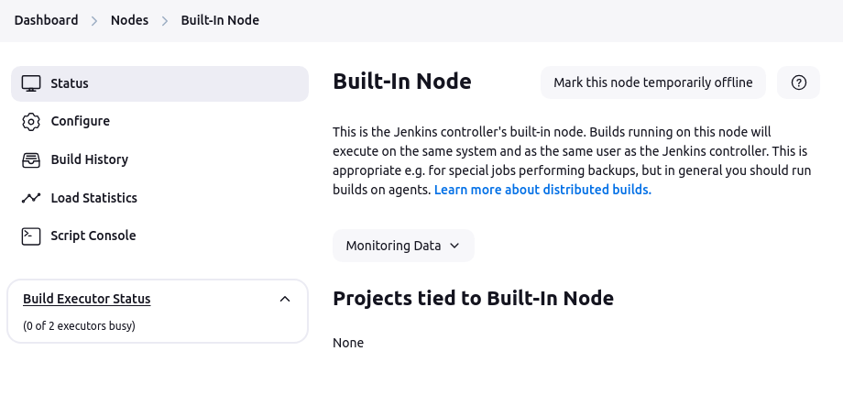

* + **Agent (slave) Node**
    - A secondary machine that connects to the master.
    - Executes jobs as assigned by the master.

### **3.4.1. Why ?**

* **Scalability** – Run builds on multiple machines to handle large projects efficiently.
* **Load Distribution** – Offload CPU/memory-intensive tasks from the master to agents.
* **Platform-Specific Builds** – Run jobs on different OS platforms (Linux, Windows, macOS).
* **Parallel Execution** – Execute multiple builds at the same time.

### **3.4.2. Configure a Node**

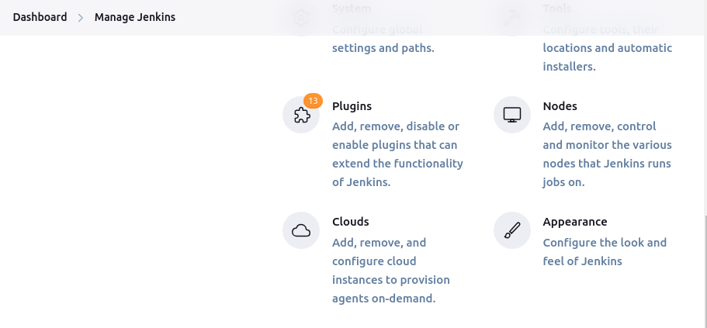

* Goto Manage Jenkins → Nodes

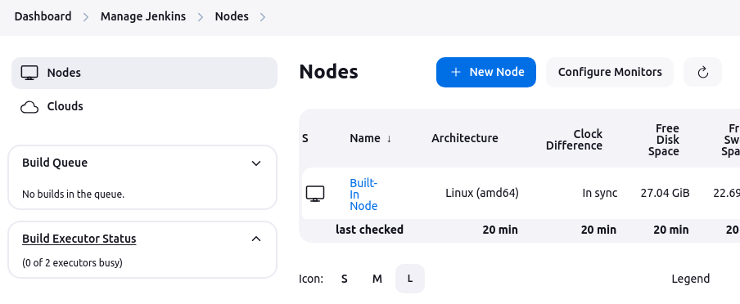

#### **3.4.2.1. Build Queue**

* “No builds in the queue” → indicates that currently, no jobs are waiting to be executed.
* If jobs are in the queue, Jenkins schedules them based on available executors.

#### **3.4.2.2. Build Executor Status**

* “0 of 2 executors busy”
* Indicates that jenkins has 2 executors ( workers that execute jobs ).
* currently , none are running a job
* If a job starts, the status changes.

#### **3.4.2.3. Nodes Section**

| Column | Description | Purpose |  |
| --- | --- | --- | --- |
| Name | The node’s name ( eg built-in node for the master/ controller node) | Identifies the node |  |
| Architecture | The system architecture (eg linux (adm64) for a 64-bit linux machine | Displays the system architecture |  |
| Clock difference | Shows if there is any time difference between the jenkins master and the agent and sync status is always yes | Shows if there is any time drift between the Jenkins controller and agents. |  |
| Free disk space | Available disk space on the node | Indicates available disk space on the node. Low space may cause build failures. |  |
| Free swap space | Amount of swap memory available | Displays available swap memory, which helps prevent crashes when RAM is full. |  |
| Free temp space | Space available in the temporary directory | Shows available space in /tmp, which is used for temporary build files and logs. |  |
| Response time | Network response time from the master to the node  To check response time from the jenkins master to a node (eg an agent with IP 192.168.1.100) | Measures the network response time from the controller to the agent. High response time may indicate network issues. |  |

#### **3.4.2.4. Create Agent1 and Configuration**

##### **3.4.2.4.1. Requirements**

* Add the credentials to allow jenkins to connect via SSH to the agent machine (172.16.203.40).
  + Under credentials, make sure added the correct SSH username and private key for the agent machine

**Username and ip address**

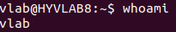

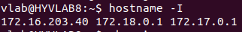

**Private key :**



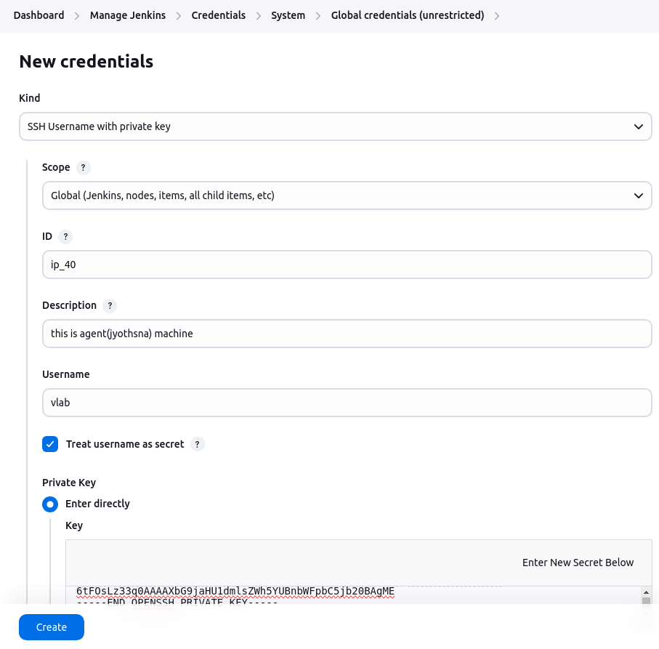

* **Remote Root Directory :** 
  + Path : /home/vara/jenkins_agent1/
  + This is the working directory on the agent machine where jenkins stores: job workspace, build artifacts, and logs
  + Give the correct ownership
  + **$ sudo chown -R vlab:vlab /home/var**

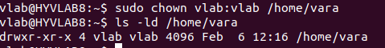

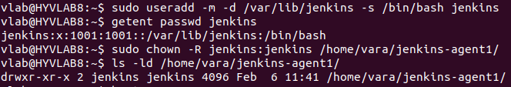

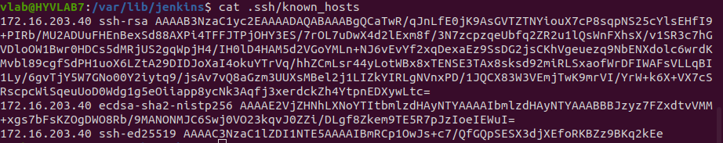

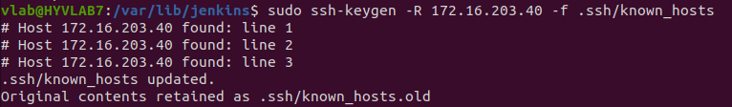

##### **3.4.2.4.2. Set up**

* Click on new node and enter the node name

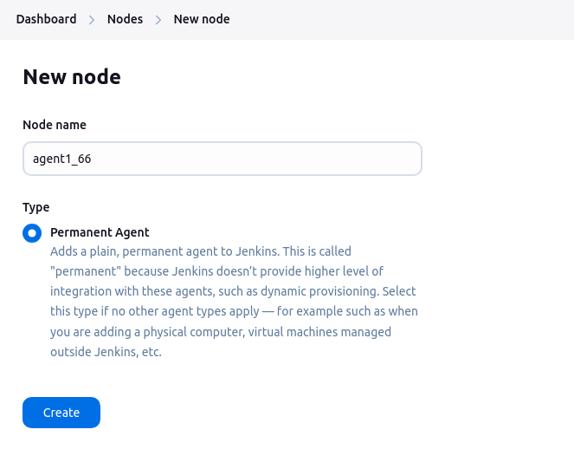

* **Name:** agent1_40 → This is the identifier for the node.
* **Description:** "This is agent1" → A human-readable description to help distinguish it.
* **Number of Executors:** 4 → This agent can run **4 parallel builds** at a time.
* **Labels:** these labels help assign specific jobs to this agent.
  + A Job can use agent {label ‘docker’} to ensure it runs on an agent with Docker installed.
* **Usage: Use this node as much as possible**
  + This means jenkins can schedule **any available job** on this node.
  + If you want to restrict it to certain jobs, change this to “**only build job with matching labels”.**
* **Launch method:**
  + **Launch agents via SSH**
  + This means the jenkins controller will connect to the agent over SSH.

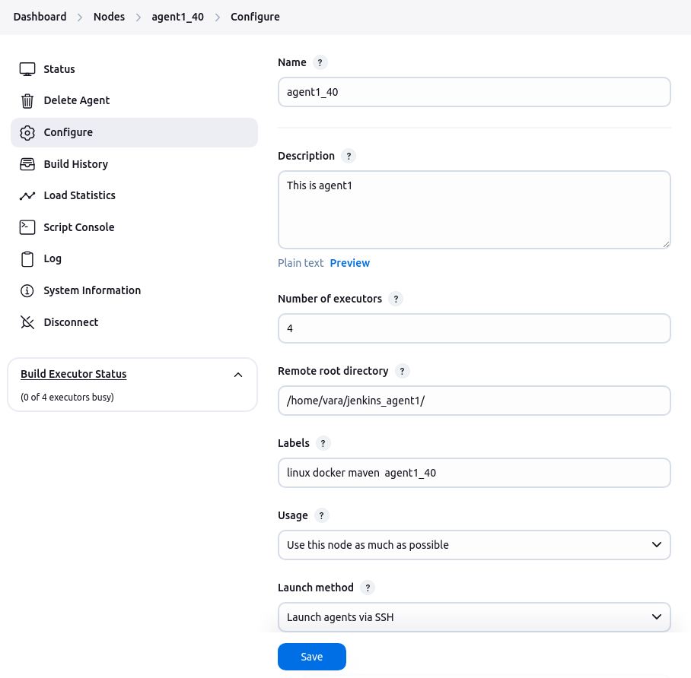

* Host : this should be the IP address or hostname of the agent machine.
* Jenkins requires **SSH credentials** to connect the agent machine.
* Check the Know Hosts file:
  + The **known hosts** file on the Jenkins master must include the agent machine’s SSH fingerprint.
  + On the Jenkins master, check if the agent machine's fingerprint is listed in ~/.ssh/known_hosts. If not, run this command from the Jenkins master to add the fingerprint: **$ ssh-keyscan 172.16.203.40 >> ~/.ssh/known_hosts**

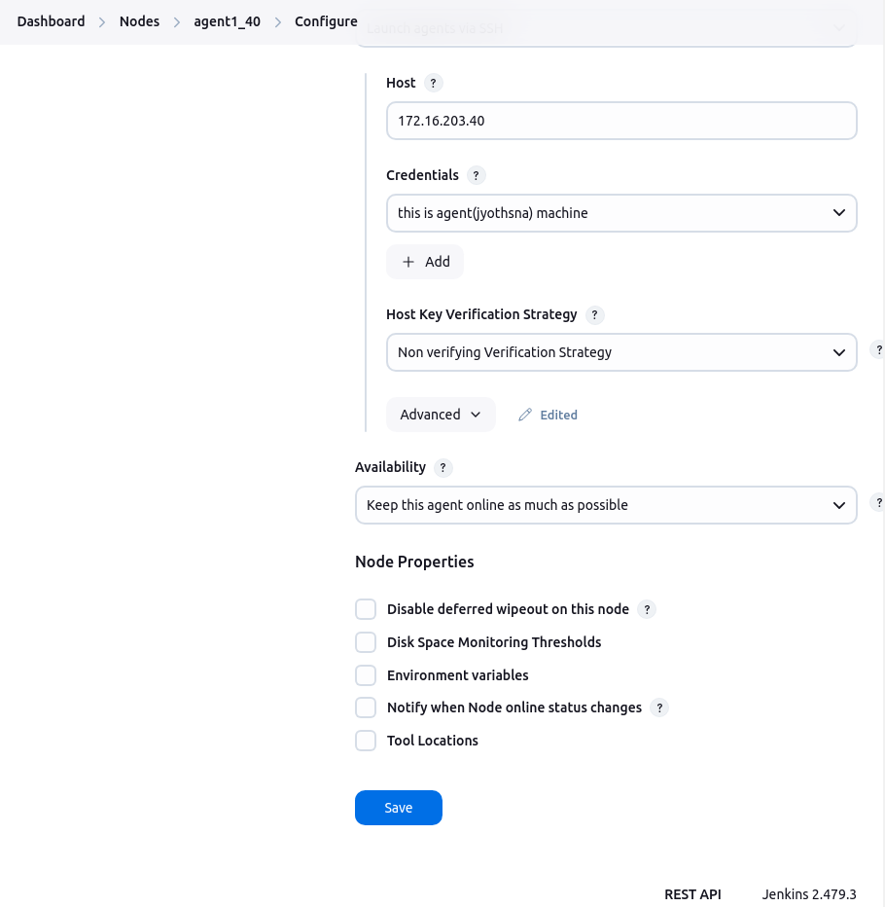

* **Host Key Verification Strategy :** 
  + **Non verifying verification strategy:** 
    - Disables host key verification and is less secure because it does not validate the server’s identity.
  + **Known Hosts File Verification Strategy:**
    - Uses a known_hosts file (typically located in the Jenkins master's or agent’s .ssh directory) to verify the SSH host key.

**$ ssh-keyscan 172.16.203.40 | sudo tee -a .ssh/known_hosts**

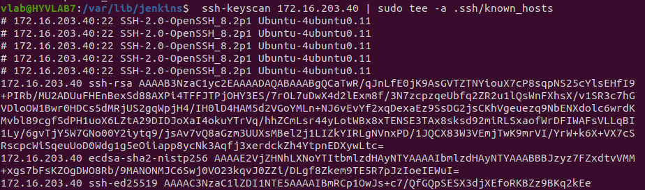

* + - When the agent connects, Jenkins compares the host key provided by the agent with the entries in the known_hosts file. If there’s a match, the connection proceeds; if not, it fails.
    - Requires maintenance of the known_hosts file, and if the remote host’s key changes (for example, due to a server rebuild), you must update the file accordingly.

**Check if the system is online or offline at status:**

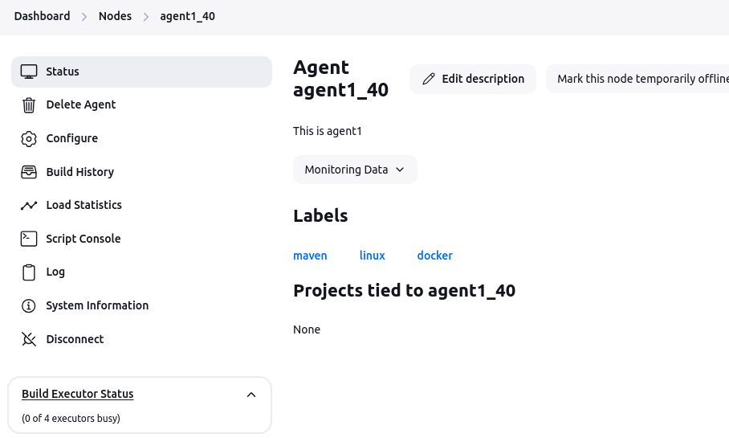

##### **3.4.2.4.3. Log**

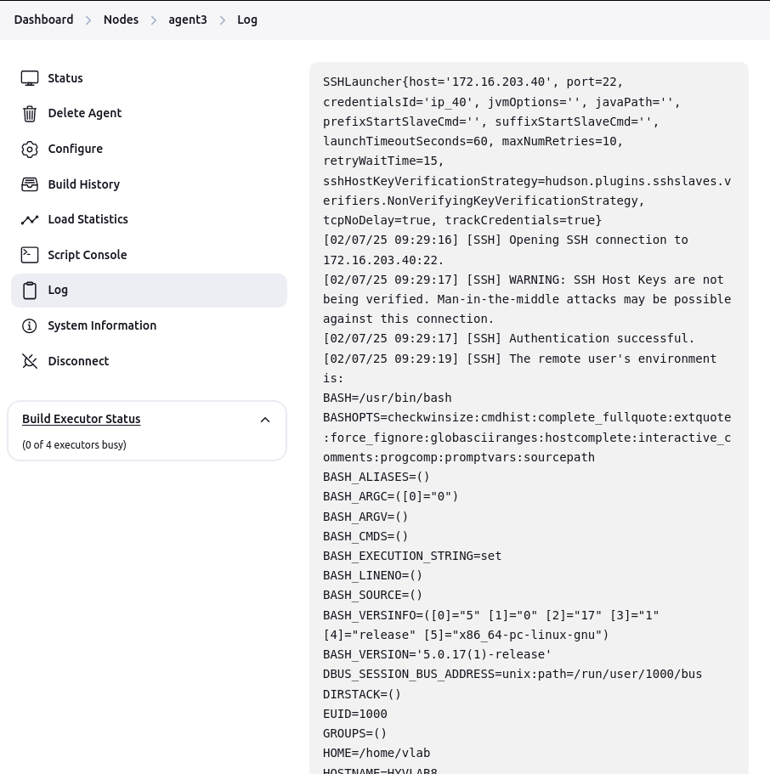

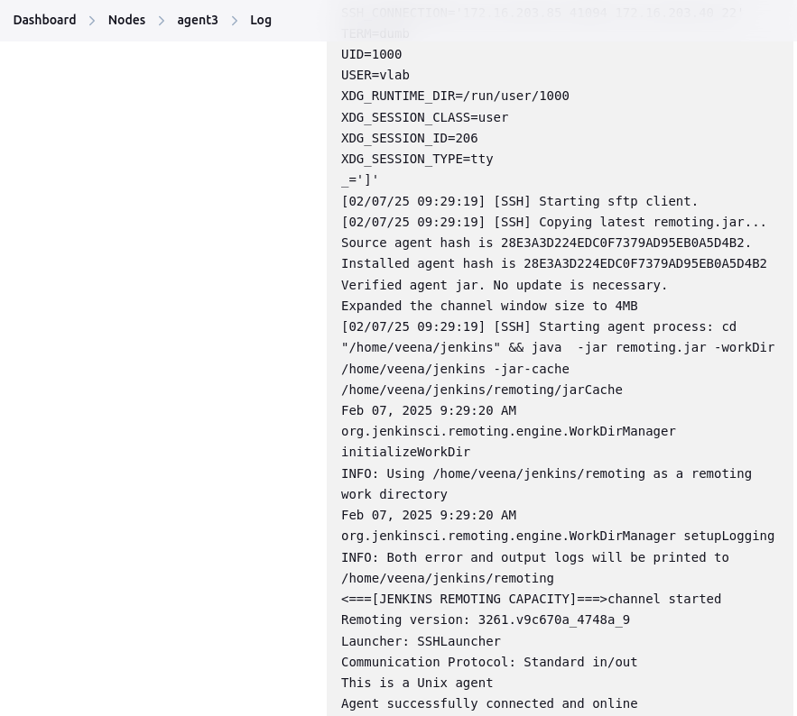

##### **3.4.2.4.4. System Information**

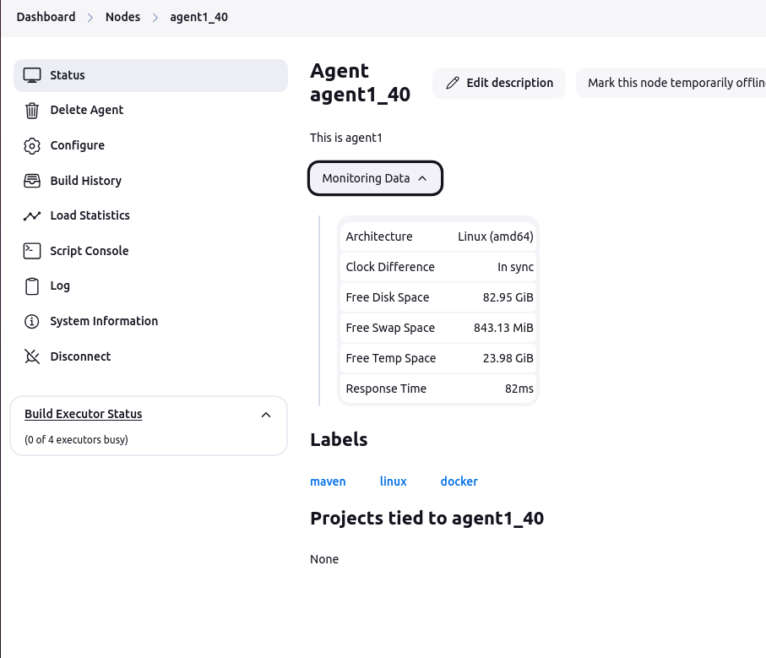

#### **3.4.2.5. Run a job on a specific node in jenkins**

* From the Jenkins dashboard, create a new Freestyle project or open an existing one.
* In the job configuration, check the option **"Restrict where this project can be run"**.
* In the field that appears, enter the **label** that you assigned to your node
* Save the configuration.
* Click **"Build Now"** to start the job.

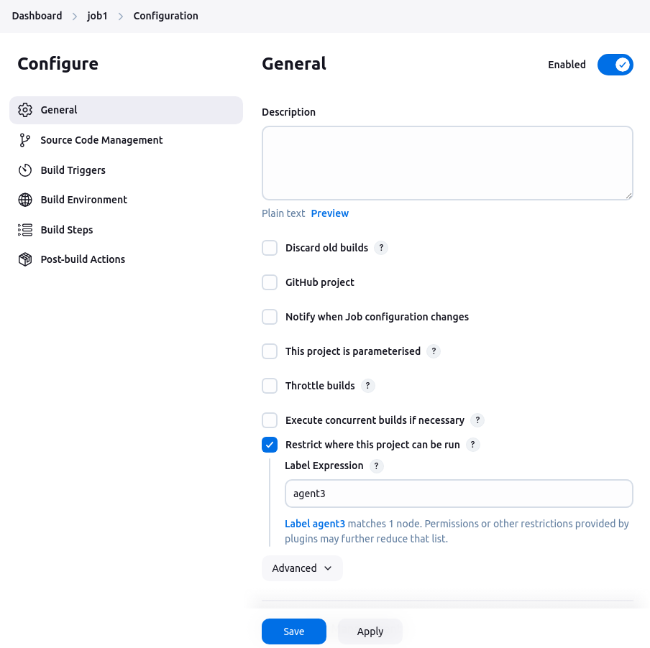

* Jenkins will dispatch the job to an available node that matches the specified label.
* **Console output:**

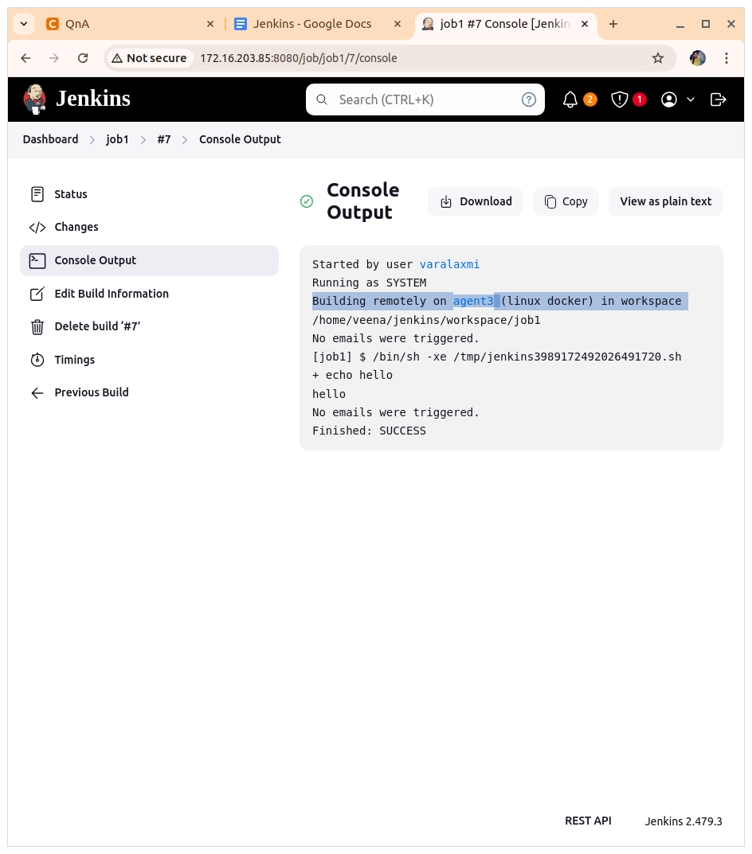

**Check Build Executor status:**

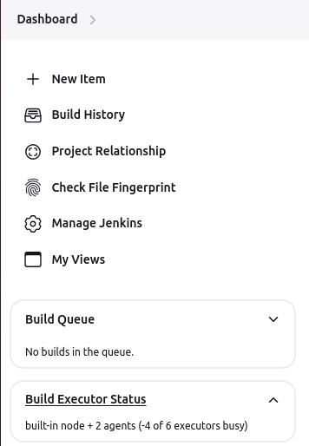

##### **3.4.2.5.1. Check the builds**

* Agents do not maintain important data. All job configuration, build logs and artifacts are stored on the controller, so it would be possible to use a temporary directory as the agent root directory.

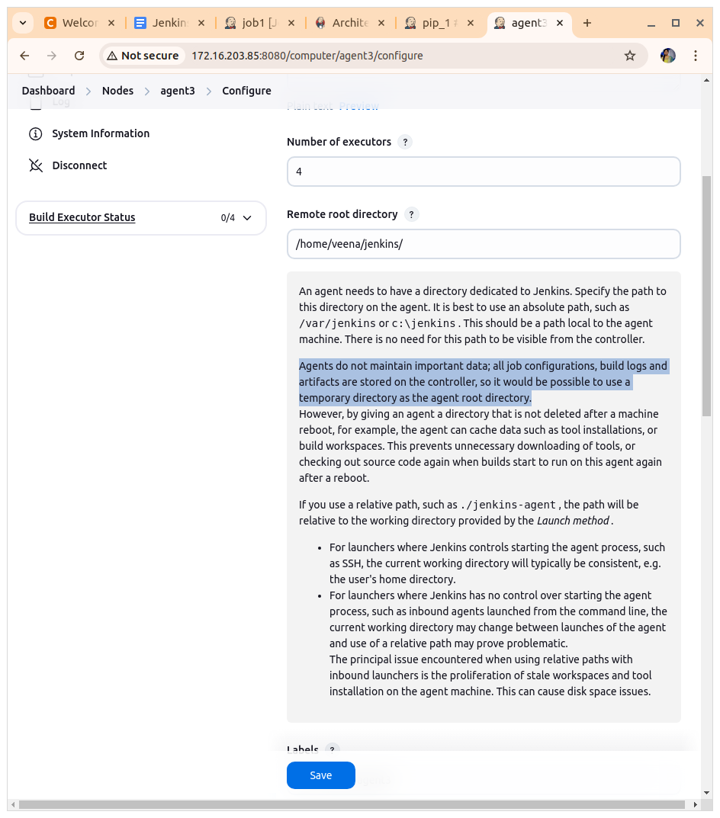

**This is master machine:**

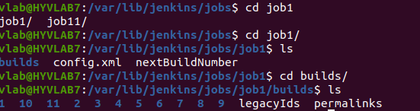

**This is Agent machine:**

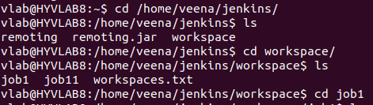

# **4. Automate Job**

* Jenkins has the ability to automatically create, update, and delete jobs based on the repositories.
* There are multiple alternatives for automatic job management
  + Use organization folders
  + Use multibranch pipelines
  + Use pipeline

## **4.1. Use organization folders**

* Management of jobs based on the repositories and branches within a source code management (SCM) organization.
* Automatically create and delete jobs as repositories or branches are added or removed from the SCM system.

### **4.1.1. Git Polling**

* Jenkins periodically checks the Git repository for changes using the configured schedule.

#### **4.1.1.1. Using HTTP**

* Click new item then enter name and select freestyle project after click ok

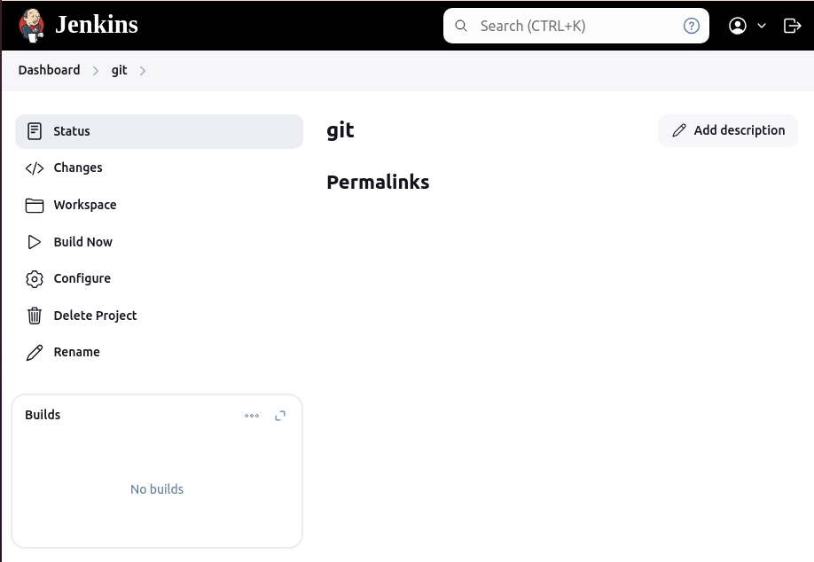

* **Add the Token to Jenkins Credentials:**
  + Go to Jenkins dashboard.
  + Click on **Manage Jenkins** > In Security select **Credentials -> add credentials**

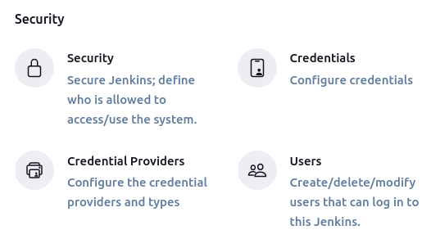

* + Set the **Kind** to **Username with password**.

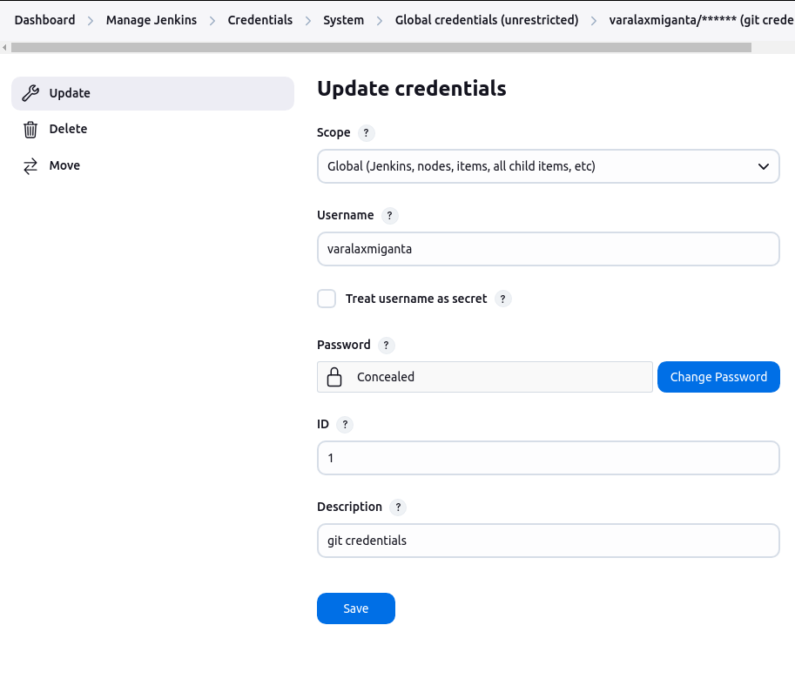

* + In **Username**, put your **GitHub username**.
  + In **Password**, paste the **Personal Access Token (PAT)** you generated.

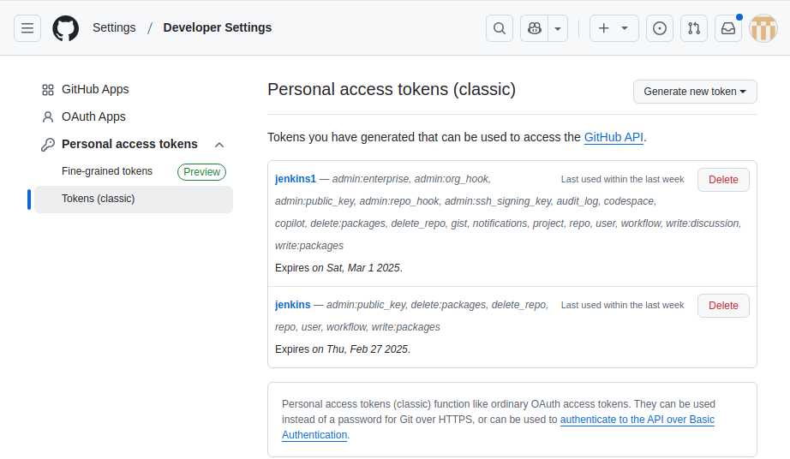

* **Update Git Repository URL in Jenkins Job:**

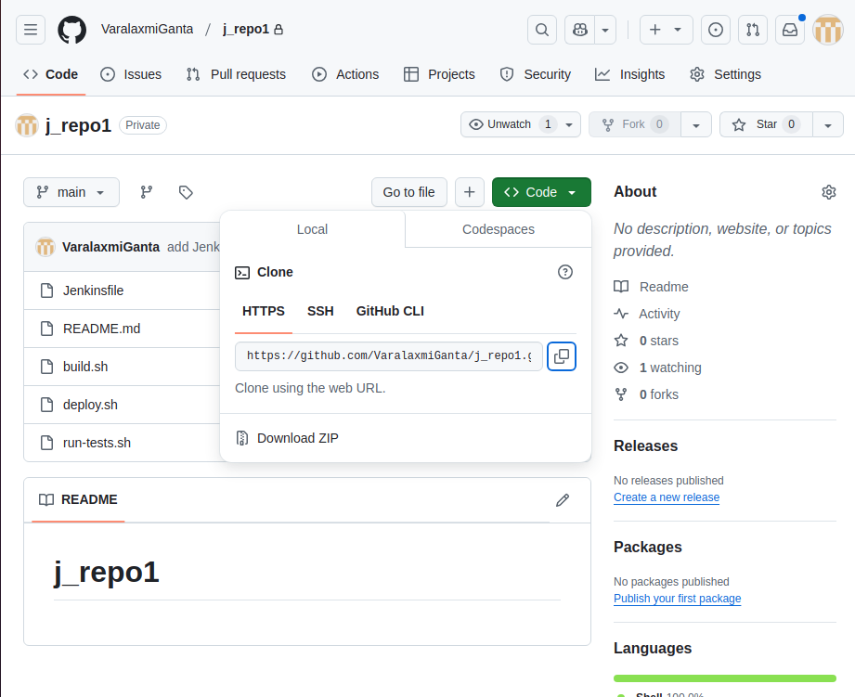

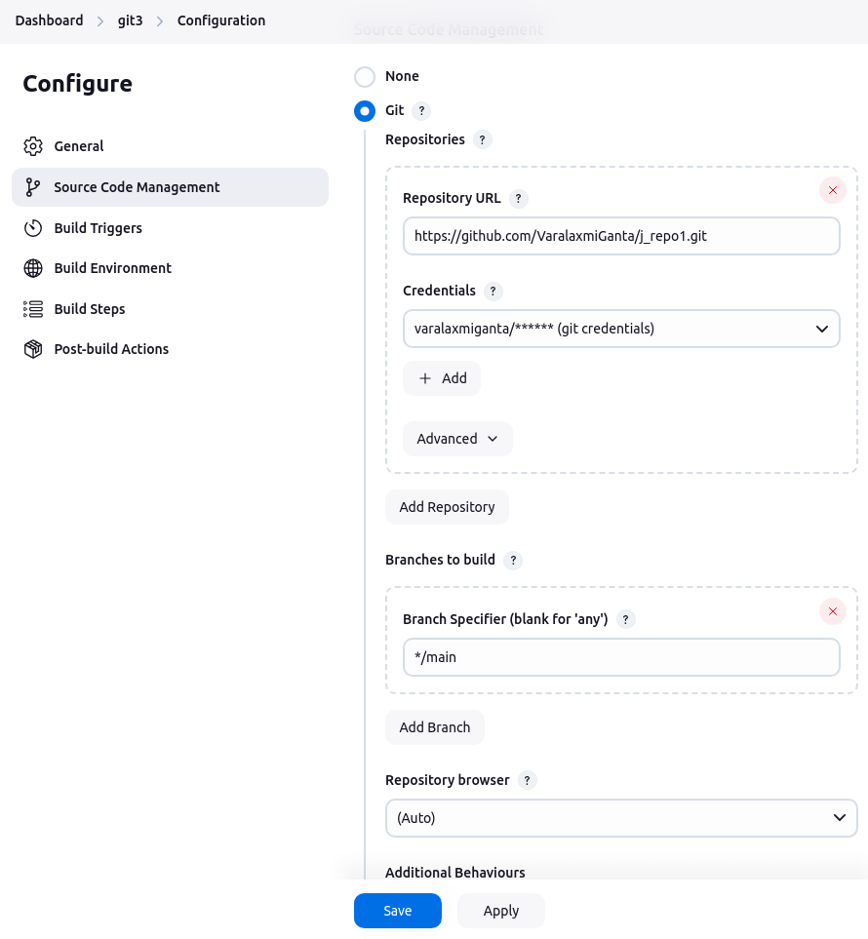

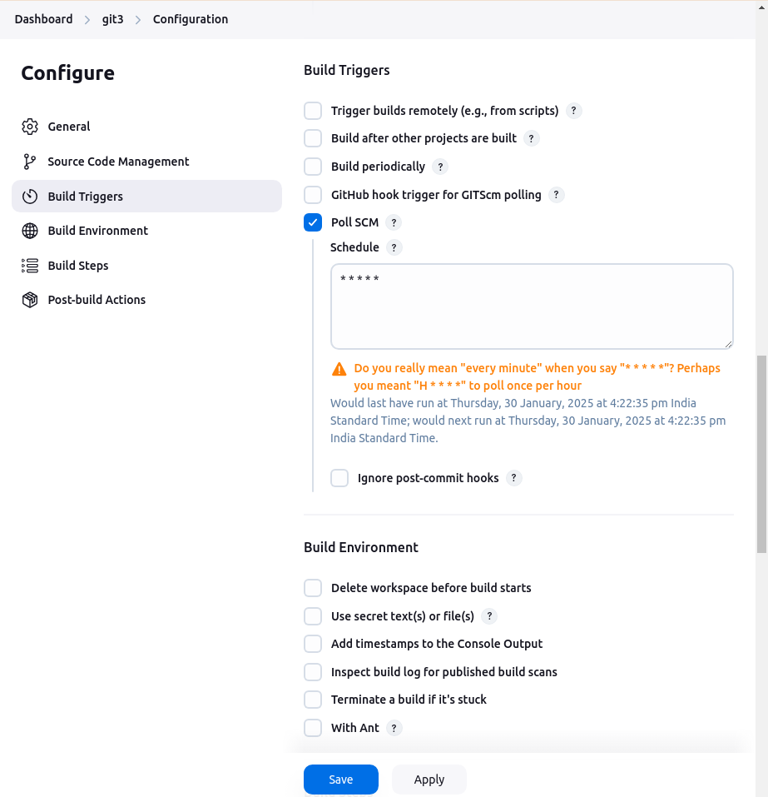

**In the Schedule :**

Goto the [https://crontab.guru/#*_*_*_*](https://crontab.guru/#*_*_*_*)

**Crontab Guru** is a simple, web-based tool that helps you understand and generate cron expressions. A cron expression is used in the cron utility to schedule jobs on Unix-like systems

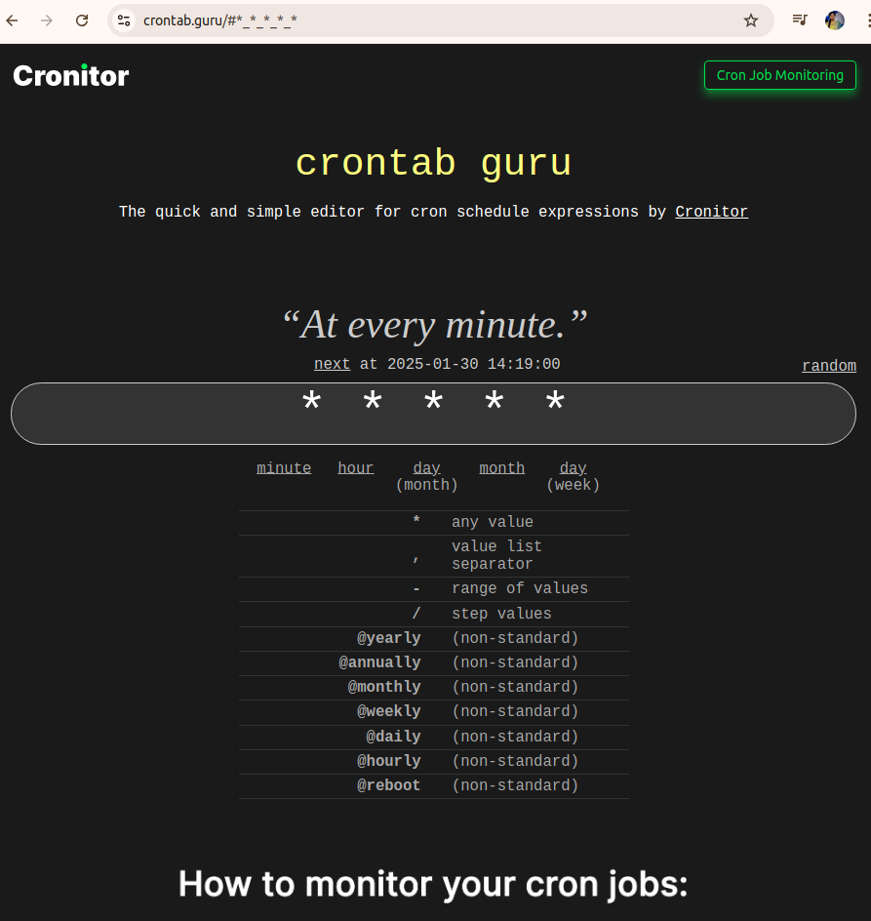

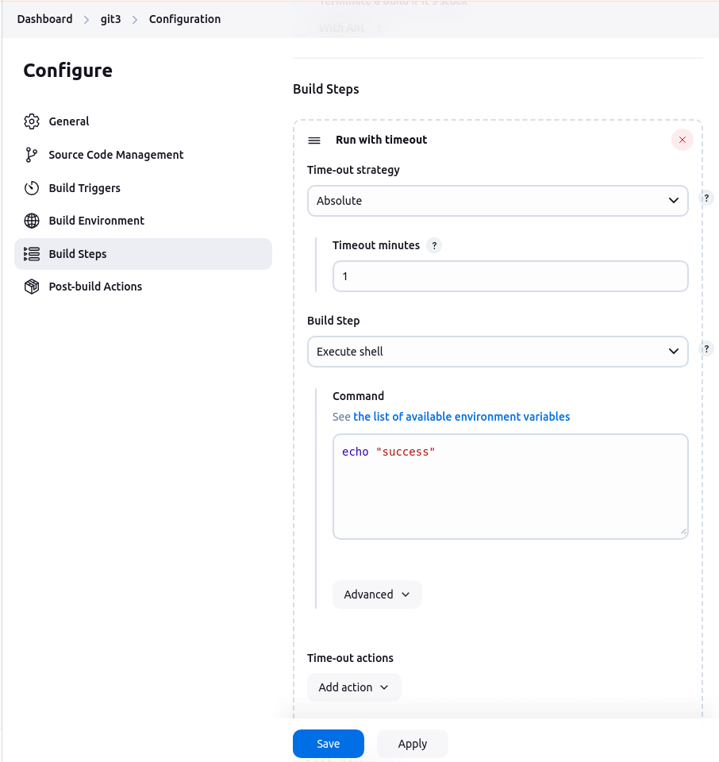

when you change the code in a Git repository, a new commit is created. If you have configured Jenkins to trigger a build upon detecting changes in the Git repository, Jenkins will automatically start a build when it detects this new commit.

#### **4.1.1.2. Using SSH**

* **Generate SSH Key Pair**:
  + $ ssh-keygen -t rsa -b 4096 -C “[your_email@gmail.com](mailto:your_email@gmail.com)”
  + **Key Pair Created**: After completing the above steps, your SSH key pair will be created:
    - The **private key** will be saved in the file: ~/.ssh/id_rsa.
    - The **public key** will be saved in the file: ~/.ssh/id_rsa.pub.

**$ ls .ssh/**

config id_rsa id_rsa.pub known_hosts known_hosts.old veena veena.pub

* + Copy the private key and it to the global credentials in jenkins.
* **Test the SSH key:**
  + $ ssh -T git@github.com

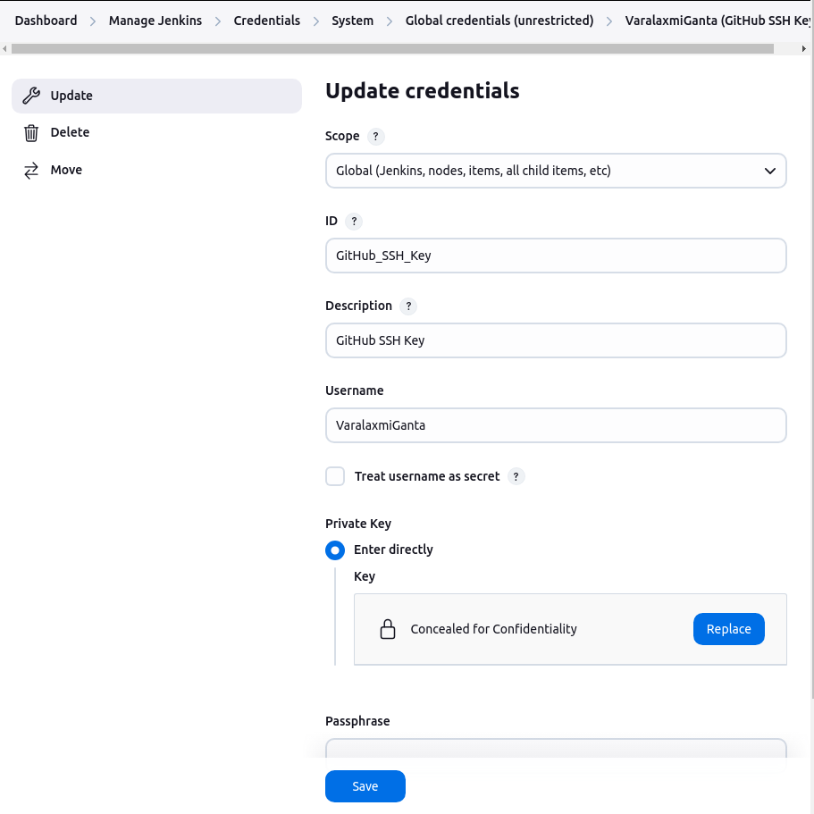

**Note :** user name must be exact

* **Configure Git Repository in Jenkins**:
  + Update your Git repository URL in Jenkins to use the SSH URL

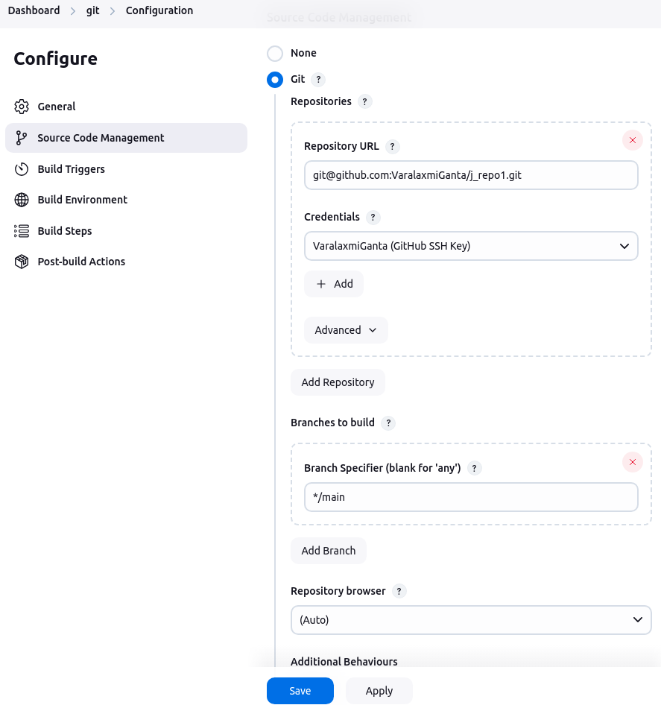

* **Git Polling Log**

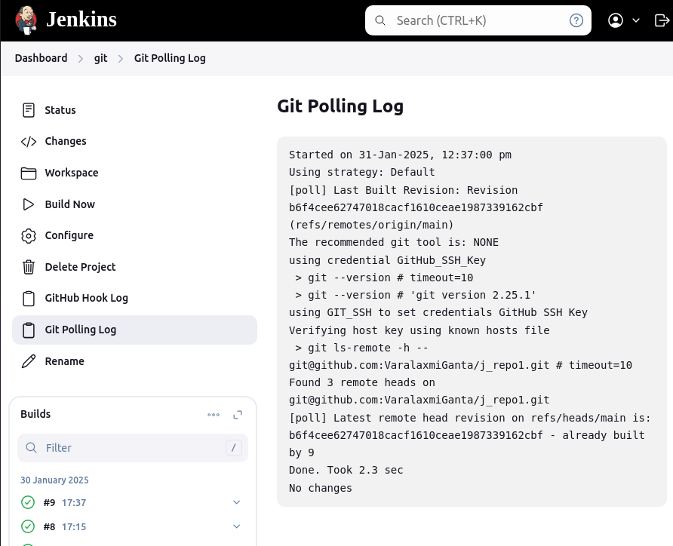

### **4.1.2. Git Webhook**

#### **4.1.2.1. Required Plugin ( Generic Webhook Trigger Plugin )**

* Can receive any HTTP request, extract any values from JSON or XML and trigger a job with those values available as variables. Works with GitHub, GitLab, Bitbucket, Jira and many more.

<https://plugins.jenkins.io/generic-webhook-trigger>

#### **4.1.2.2. ngrok**

* **ngrok** is a tool that creates a secure tunnel from a public endpoint (usually an internet address) to your local machine, enabling external access to local applications or services behind a firewall or NAT (Network Address Translation).
* It is especially useful for testing, development, and sharing web services or APIs running on your local machine.
* **Login into the ngrok dashboard:**

<https://dashboard.ngrok.com/get-started/setup/linux>

* Create one account to access it.
* **Install ngrok via Apt with the following command:**

$ curl -sSL https://ngrok-agent.s3.amazonaws.com/ngrok.asc \

| sudo tee /etc/apt/trusted.gpg.d/ngrok.asc >/dev/null \

&& echo "deb https://ngrok-agent.s3.amazonaws.com buster main" \

| sudo tee /etc/apt/sources.list.d/ngrok.list \

&& sudo apt update \

&& sudo apt install ngrok

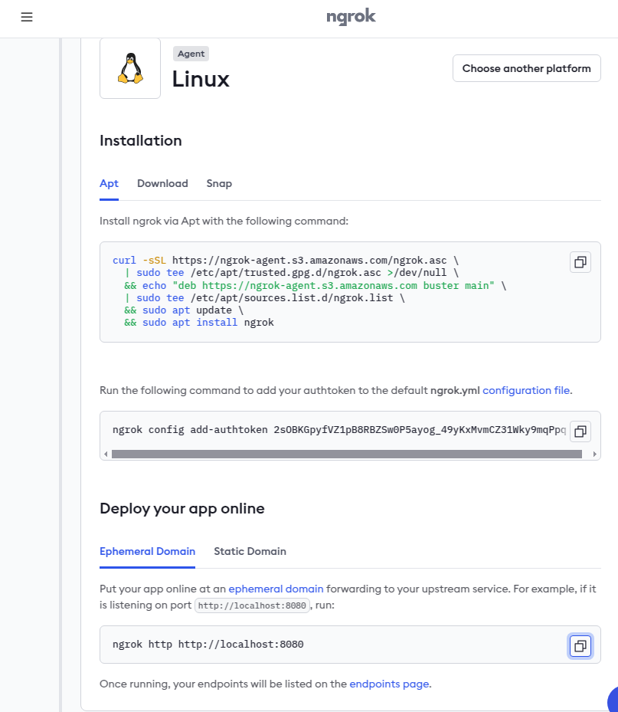

* **Run the following command to add your authtoken to the default ngrok.yml**

$ sudo ngrok config add-authtoken 2sOBKGpyfVZ1pB8RBZSw0P5ayog_49yKxMvmCZ31Wky9mqPpq

* **Open terminal**

**$ sudo ngrok http** [**http://localhost:8080**](http://localhost:8080)

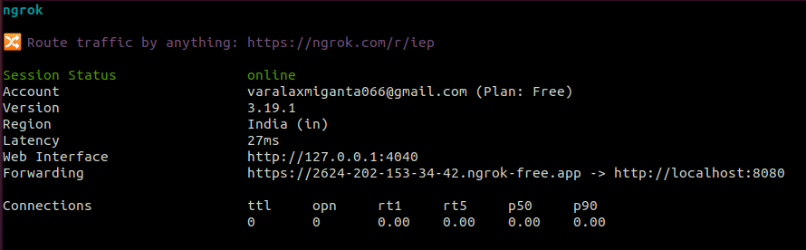

* **In github add webhook for one required repo:**
  + Copy the forwarding url into the payload URL.
  + Select content type is **application/json**
  + Secret key is get from the jenkins:

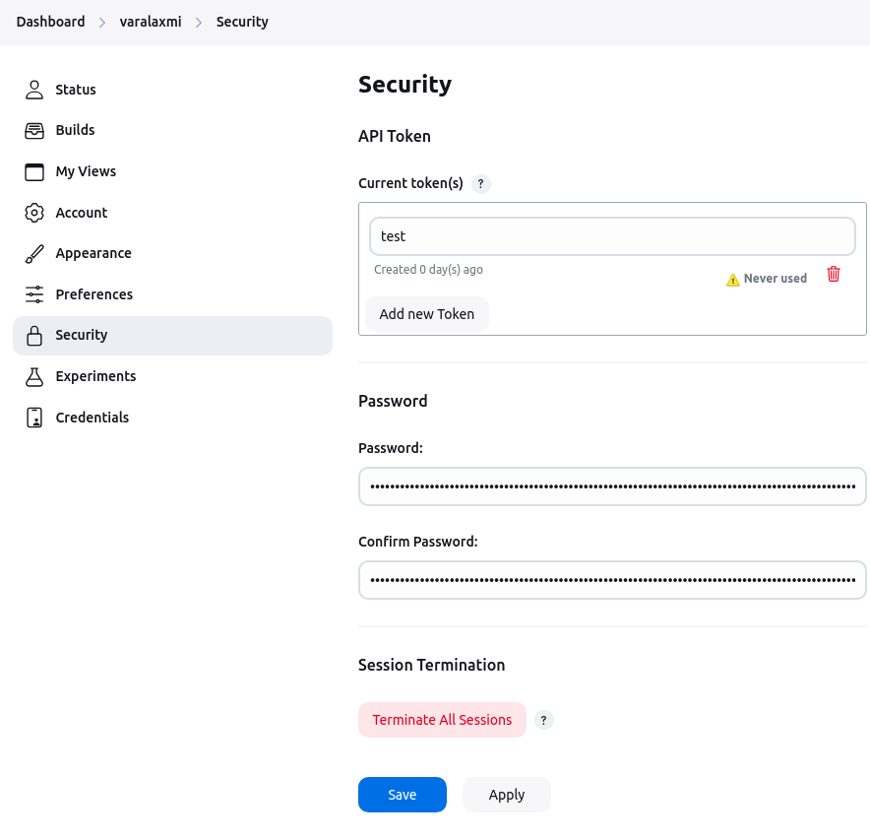

* + - Open jenkins dashboard → click admin icon →security
    - In the API Token add new token → first enter name and click on generate token copy it and paste it on the jenkins.

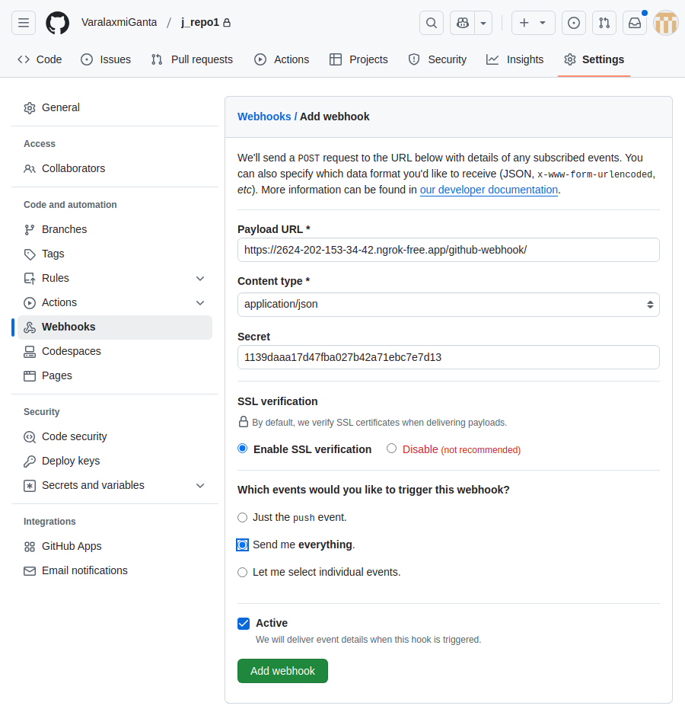

* + Add the webhook it looks like this

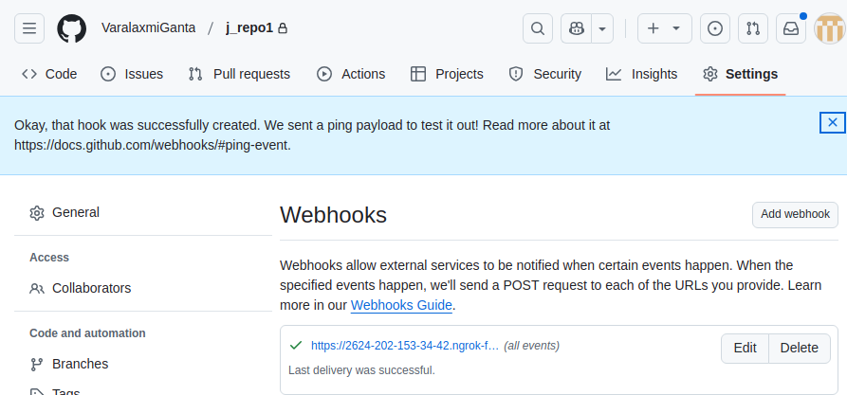

* Goto jenkins dashboard create a job for Freestyle

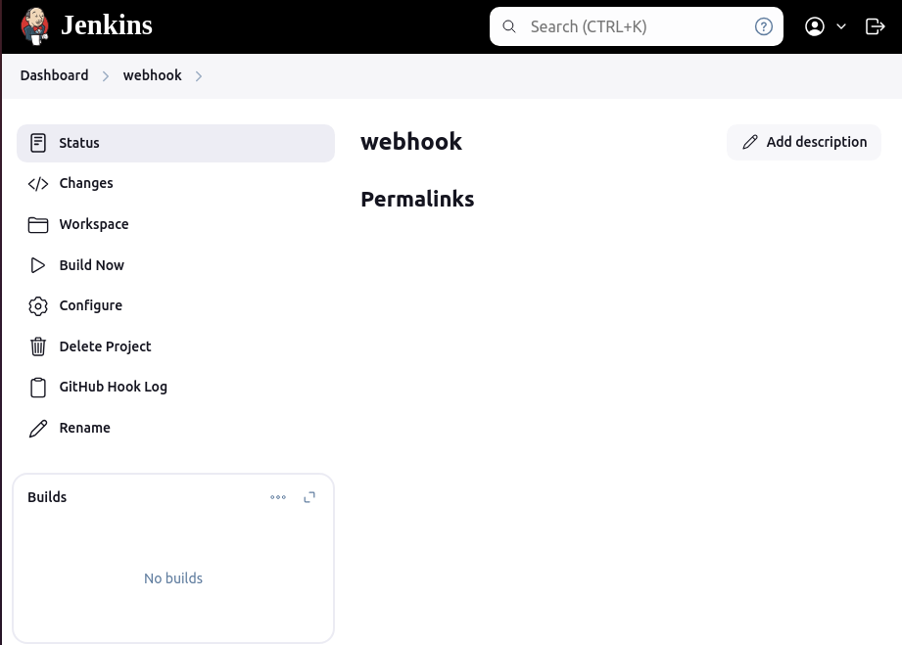

* Change the configure

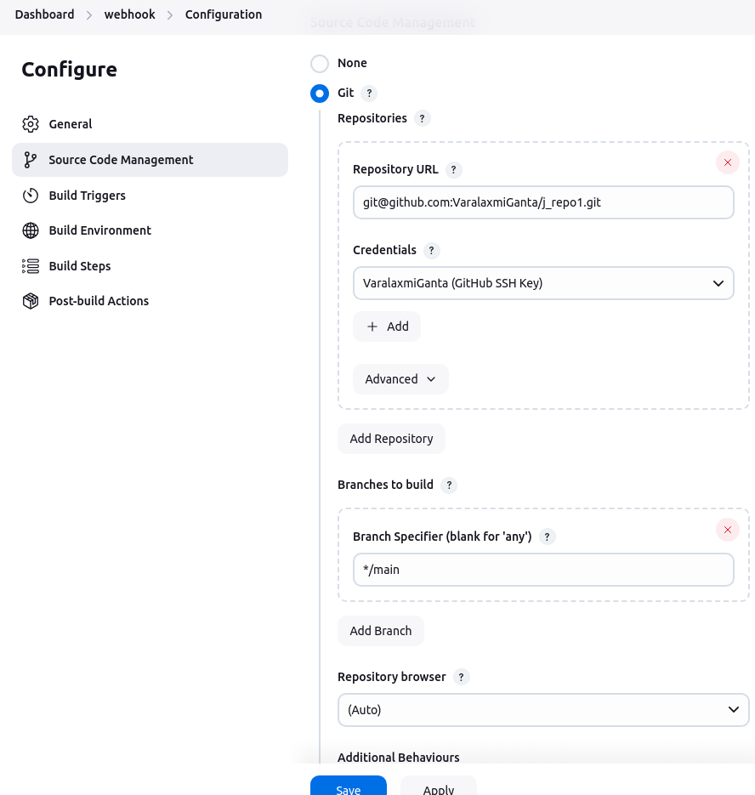

* Select build triggers is **GitHub hook trigger for GITScm polling**

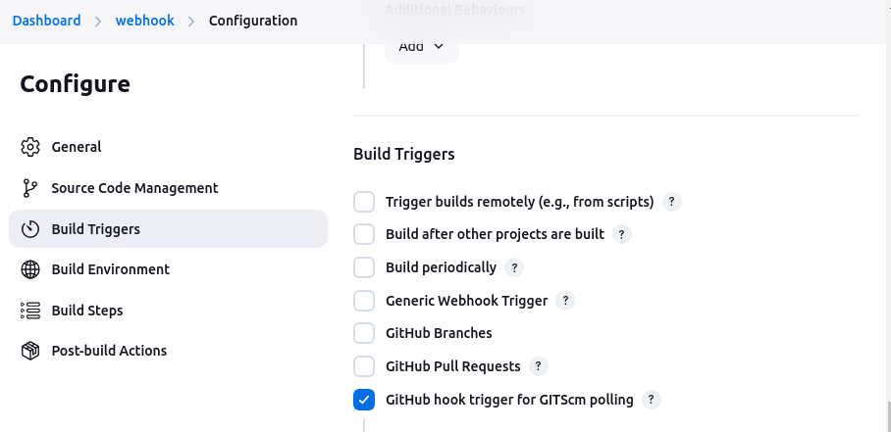

* Change the script in the git repo

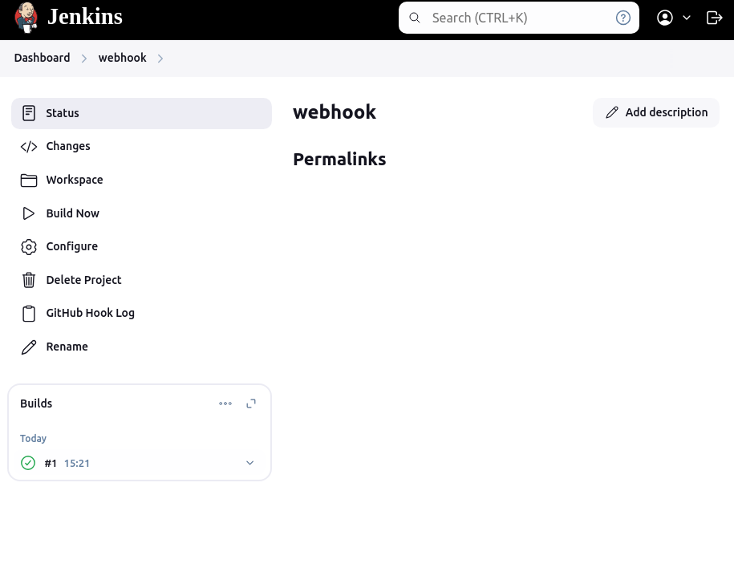

* Jenkins will be trigger the changes

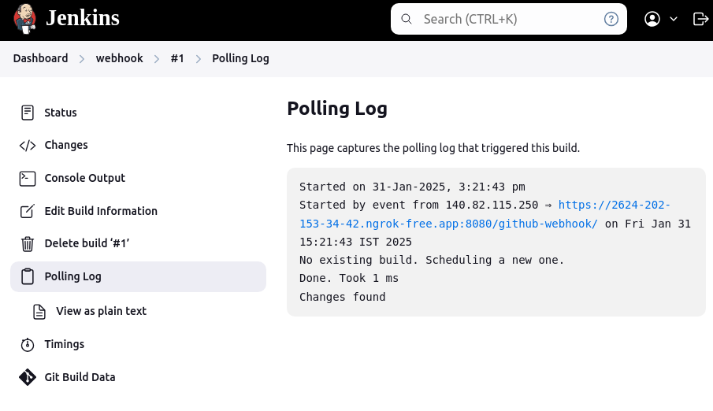

### **4.1.3. Webhook Trigger for Multibranch Pipeline**

**Note :**

* Check the agent endpoints if it online or not

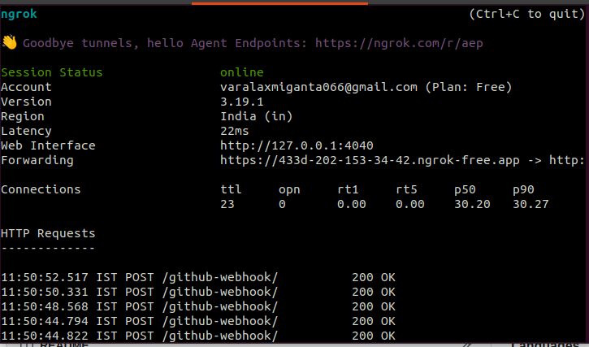

* Give appropriate permissions to the files in your repository for Jenkins to access

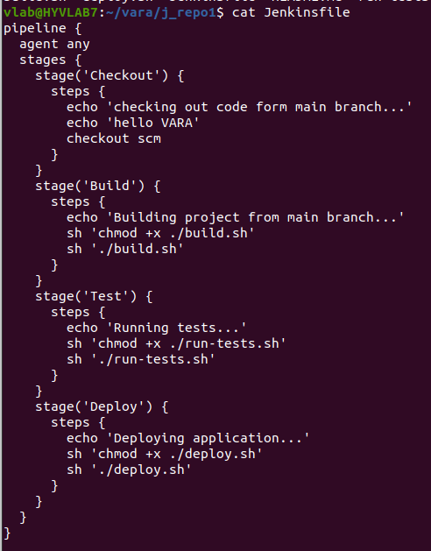

### 

#### **4.1.3.1. Plugin (Multibranch Scan Webhook Trigger)**

* Trigger that can receive any HTTP request and trigger a multibranch job scan when the token matched.

#### **4.1.3.2. Each branch of repository can have its own Jenkinsfile**

**Note :**

* List all the branches for both remote and local

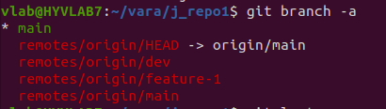

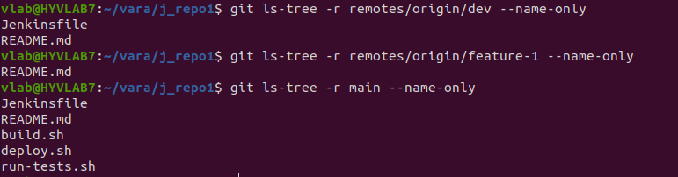

* In the above dev and main branches are having Jenkinsfile so if getting any new commit from dev or main branches then webhook triggers but not for feature-1 because there is no jenkinsfile in that branch.
* Create a Multibranch Pipeline Job:
  + Open Jenkins, and click on **New Item**.
  + Choose **Multibranch Pipeline**, and give it a name.
  + Click **OK** to create the job.

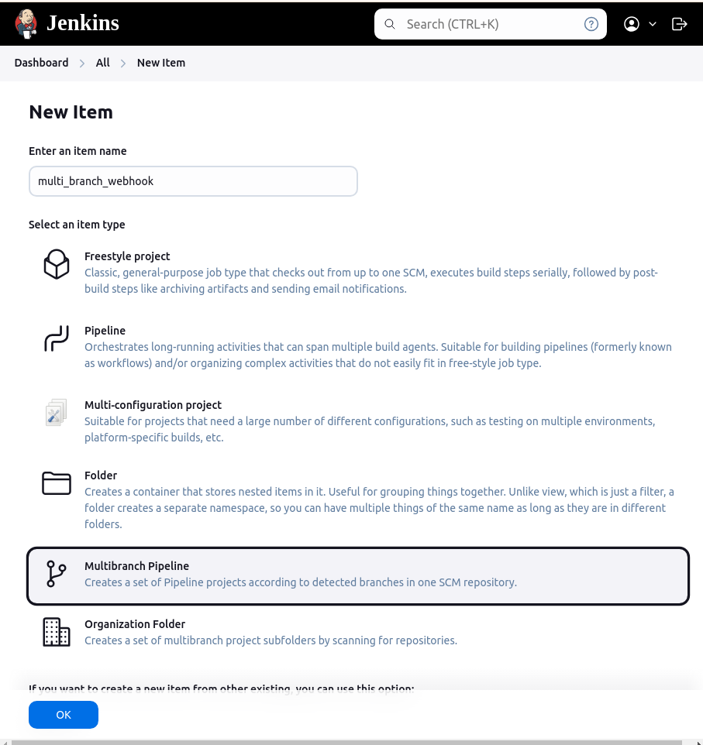

* Configure the Multibranch Pipeline Job:
  + Under the **Branch Sources** section:
    - Select your source control management **GitHub**
    - Provide the repository URL.
    - Configure credentials if needed.

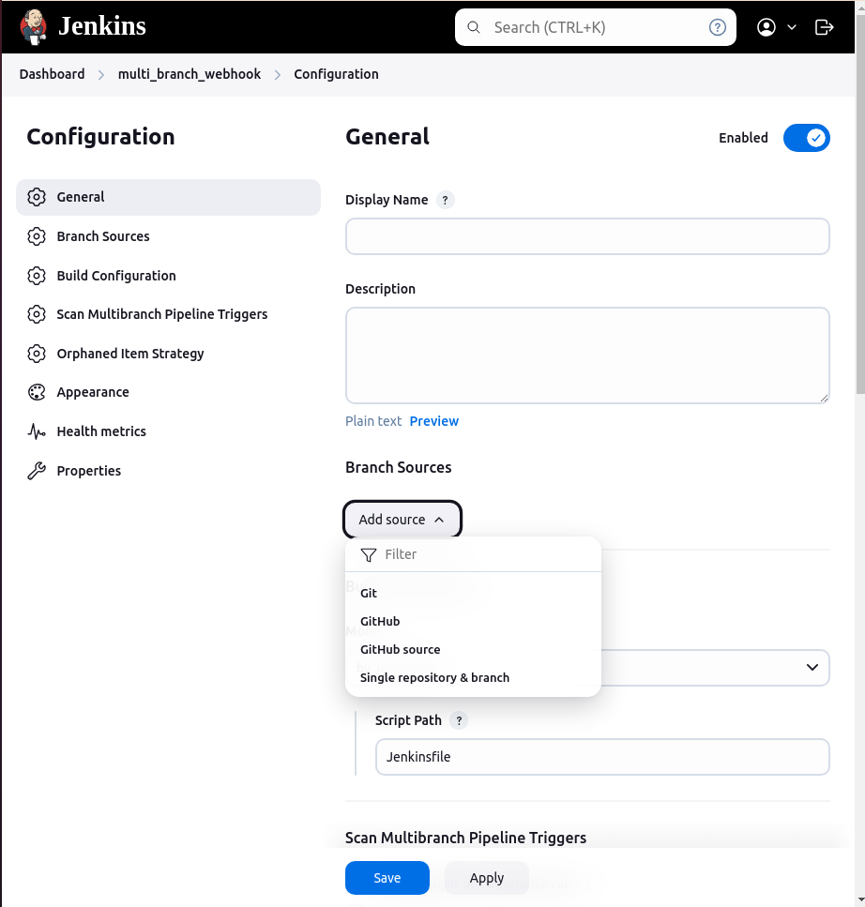

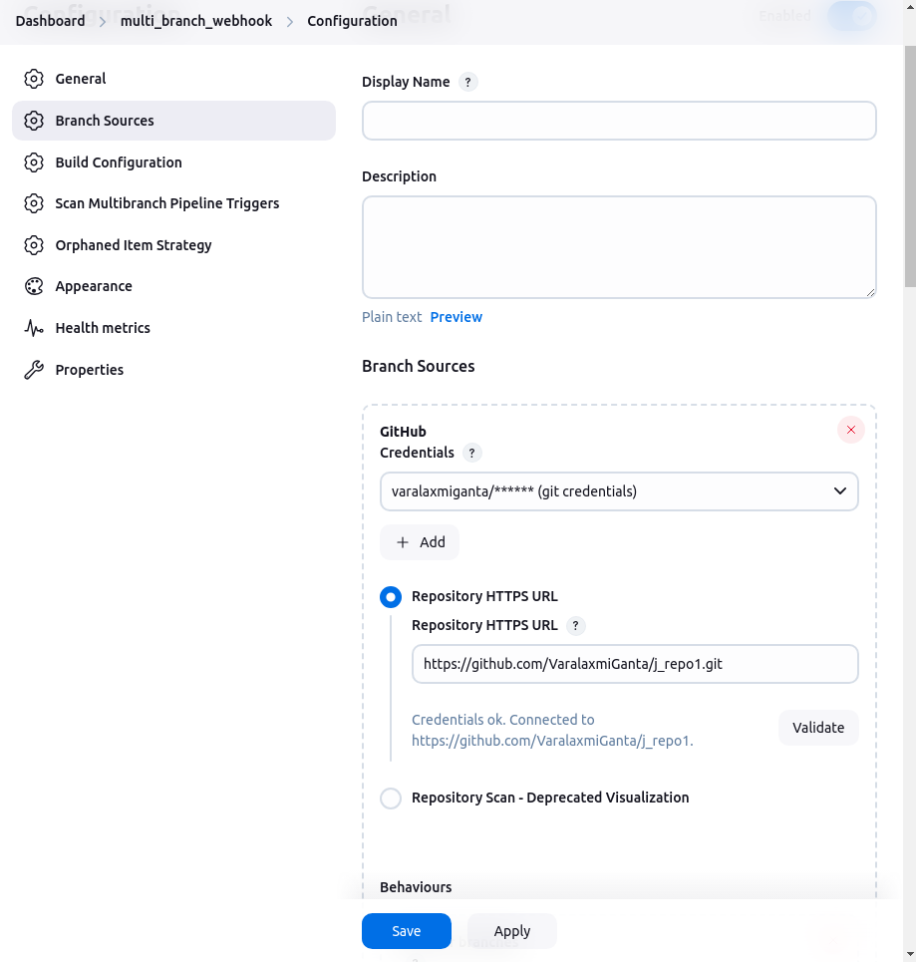

This is from ngrok endpoint

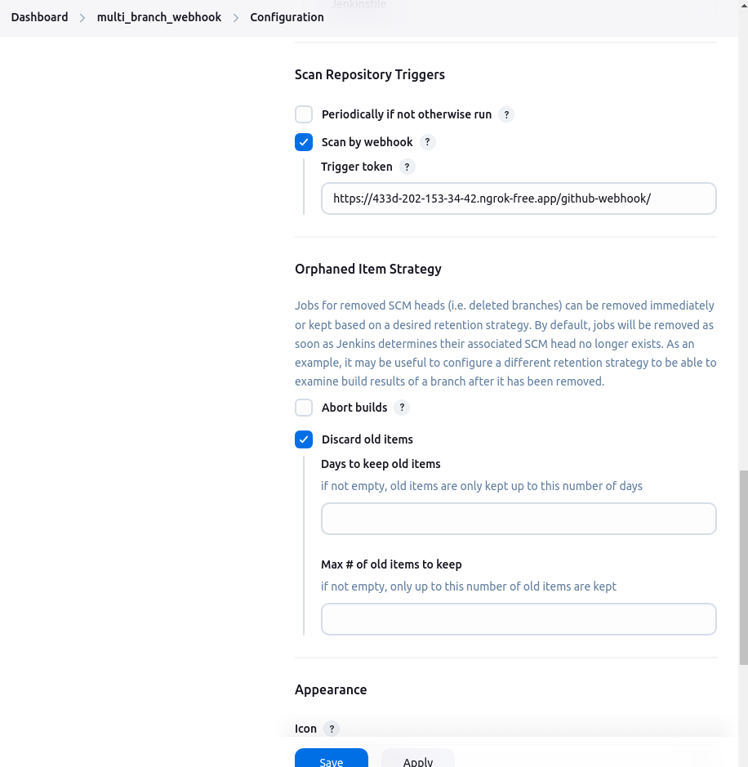

Save the configurations

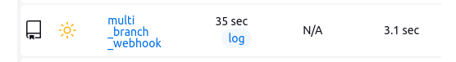

* Jenkins should automatically detect the change via the webhook and trigger the appropriate branch's pipeline.

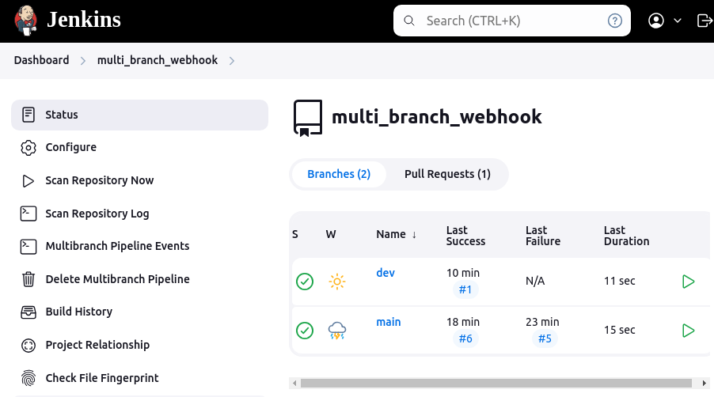

##### **4.1.3.2.1. Scan Repository Log**

**Started by user [varalaxmi](http://172.16.203.85:8080/user/vara)**

**[Mon Feb 03 12:26:35 IST 2025] Starting branch indexing...**

**12:26:36 Connecting to** [**https://api.github.com**](https://api.github.com/) **using varalaxmiganta/****** (git credentials)**

**Examining** [**VaralaxmiGanta/j_repo1**](https://github.com/VaralaxmiGanta/j_repo1)

**Checking branches...**

**Getting remote branches...**

**Checking branch** [**main**](https://github.com/VaralaxmiGanta/j_repo1/tree/main)

**‘Jenkinsfile’ found**

**Met criteria**

**No changes detected: main (still at 34a17a27be612cd84fa8d92ad68a32bc3304971e)**

**Checking branch** [**dev**](https://github.com/VaralaxmiGanta/j_repo1/tree/dev)

**‘Jenkinsfile’ found**

**Met criteria**

**No changes detected: dev (still at b87dbbcbaef6ffbbd94f74a38c4c15d548c1b78e)**

**Checking branch** [**feature-1**](https://github.com/VaralaxmiGanta/j_repo1/tree/feature-1)

**‘Jenkinsfile’ not found**

**Does not meet criteria**

**3 branches were processed**

**Checking pull-requests...**

**Getting remote pull requests...**

**Checking pull request** [**#2**](https://github.com/VaralaxmiGanta/j_repo1/pull/2)

**‘Jenkinsfile’ not found**

**Does not meet criteria**

**Checking pull request** [**#1**](https://github.com/VaralaxmiGanta/j_repo1/pull/1)

**‘Jenkinsfile’ found**

**Not mergeable, but will be built anyway**

**Met criteria**

**No changes detected: PR-1 (still at b87dbbcbaef6ffbbd94f74a38c4c15d548c1b78e)**

**2 pull requests were processed**

**Finished examining VaralaxmiGanta/j_repo1**

**[Mon Feb 03 12:26:40 IST 2025] Finished branch indexing. Indexing took 5 sec**

**Finished: SUCCESS**

# 